

**Frankfurt University of Applied Sciences**

Faculty of Electrical Engineering

Bachelor Thesis

Design, Implementation, and Characterisation

of an Autonomous Wireless Agrometeorology Station

submitted by

Do Nguyen Hoang

Matriculation number: 1235052

|  |  |  |
| --- | --- | --- |
| Supervisor | : | Dr.-Ing. Udo Klein |
| Second supervisor | : | M.Sc. Tran Quang Nhu |

*(This page is intentionally left blank)*

# Disclaimer

I declare that this report is the product of my work, unless otherwise referenced. All opinions, result, conclusions, and recommendations are my own to the best of my knowledge and may not represent the policies or opinions of the Vietnamese-German University.

_____________________

Do Nguyen Hoang

# Abstract

Precision agriculture is the key for productivity. However, it cannot be achieved via traditional methods of human observations and experience, which are still widely applied while technological advances remain in the uncharted territories. This project aims at building a sensor system that can remotely monitor the meteorology of a farming area with a high precision and consistency.

The main objective of this design is the development of a self-contained system running with little to no human intervention. The system features a collection of sensors to sample targeted environment parameters and allows the data to be accessed online, while remaining off-grid, at a minimum cost. The conceptual design suggests the viability of a such goal, though not without constraints.

# Table of Contents

Disclaimer i

Abstract ii

Table of Contents iii

List of Figures v

List of Tables vii

Abbreviations viii

2. Introduction 2

2.1. Background 2

2.2. Objectives 2

2.3. Thesis structure 2

3. Module overview 3

4.1. STM32F103C8T6 Microcontroller 3

4.2. Sensor Units 4

4.2.1. Anemometer 4

4.2.2. Wind Vane 5

4.2.3. Rain Gauge 7

4.2.4. BME280 9

4.2.5. DS18B20 10

4.3. SX1278 for Wireless Communication 12

4.4. Other Modules 13

4.4.1. DS3231 13

4.4.2. microSD Card 14

4.4.3. Analogue Low-pass Filter (LPF) 14

4.5. System Powering 17

4.6. Server 17

5. Implementation 19

5.1. STM32F103C8T6 Microcontroller 19

5.2. Sensor units 23

5.2.1. Anemometer 23

5.2.2. Wind Vane 27

5.2.3. Rain Gauge 34

5.2.4. BME280 35

5.2.5. DS18B20 36

5.3. SX1278 37

5.4. Other Modules 38

5.4.1. DS3231SN 38

5.4.2. microSD Card 39

5.5. System Powering 39

5.6. Server 41

6. Experimental Characterisation 42

6.1. Anemometer 42

6.2. Wind Vane 49

6.3. Rain Gauge 49

6.4. Temperature Sensors 49

6.5. Hygrometer – Barometer 49

6.6. LoRa Connectivity – ThingSpeak 49

6.7. LoRa Range Test 49

6.8. Humidity Sensing Unit 52

6.9. InfluxDB Online Database 54

7. Conclusion and Future Work 55

References ix

# List of Figures

Figure 2‑1. The STM32F103C8T6-based Blue Pill board in the project 3

Figure 2‑2. The counterfeit read as an STM32F103 Medium Density device with a 128-KB Flash memory 4

Figure 2‑3. The three-cup anemometer [1] 5

Figure 2‑4. “The internal reed switch of the anemometer” [1] 5

Figure 2‑5. The wind vane [1] 6

Figure 2‑6. Electrical circuit of the wind vane [1] 6

Figure 2‑7. Examples of wind vane-reading circuits 7

Figure 2‑8. The structure of the rain gauge [1] 8

Figure 2‑9. Rain gauge’s reed switch on a PCB upon removal of base chassis cover cap [1] 8

Figure 2‑10. Orifice dimensions (in mm) of the funnel [1] 8

Figure 2‑11. Dimensions of a BME280 sensor [18] 9

Figure 2‑12. BME280 module with header strip [20] 9

Figure 2‑13. DS18B20 hardware 11

Figure 2‑14. Circuitry examples for communication with DS18B20 [1], [22] 12

Figure 2‑15. SX1278 LoRa module in test 13

Figure 2‑16. DS3231SN pinout module 14

Figure 2‑17. Passive first-order RC LPF circuit 15

Figure 2‑18. Frequency response of an example RC LPF with $R = 1 kΩ$ and $C = 100 nF$ under simulation [1] 16

Figure 2‑19. Concept of the solar powering system 17

Figure 2‑20. The nodeMCU ESP8266 used at the server side of the project [1] 18

Figure 4‑1. The schematic of the STM32F103C8T6-housed Blue Pill board [7] 20

Figure 4‑2. Simplified Blue Pill schematic with removed unused parts 22

Figure 4‑3. Bus connections with the Blue Pill board 23

Figure 4‑4. Circuitry for testing the anemometer in ideal conditions 24

Figure 4‑5. “An instance of noise spikes captured in an oscilloscope” [1] 25

Figure 4‑6. Bypass capacitor test circuitry using the reed switch from the anemometer 26

Figure 4‑7. Reed switch debounced by the 68-nF bypass capacitor 26

Figure 4‑8. Circuitry for interfacing with the anemometer 27

Figure 4‑9. Voltage divider circuitry with ADC module 28

Figure 4‑10. Derivation of the Norton equivalent of the voltage divider 29

Figure 4‑11. An instance of Rexternal = 3.0kΩ input to the voltage step-calculating sheet 30

Figure 4‑12. “A noise instance captured during a test on the wind vane” [1] 31

Figure 4‑13. Frequency response of the 1.013-kHz RC LPF 32

Figure 4‑14. Step response of the 1.013-kHz RC LPF 33

Figure 4‑15. Circuitry for reading the wind vane 34

Figure 4‑16. Circuitry for interfacing with the rain gauge 35

Figure 4‑17. BME280 setup for the I2C protocol 36

Figure 4‑18. The concept of a DS18B20 powered via an external power supply VP 36

Figure 4‑19. Final circuitry for interfacing the DS18B20 with the microcontroller 37

Figure 4‑20. Hardware setup for SX1278 LoRa module 38

Figure 4‑21. Hardware setup with the DS3231SN RTC module 39

Figure 4‑22. Block diagram of the system powering circuitry 39

Figure 5‑1. Axial Fan Module MFP107 by TecQuipment [60] 42

Figure 5‑2. Linear association between the anemometer’s and the Axial Fan Module’s wind speeds 43

Figure 5‑3. Wind speed factors by the read wind speed from the anemometer 44

Figure 5‑4. Curve Fitting result for N = 1 46

Figure 5‑5. Curve Fitting result for N = 2 47

Figure 5‑6. Curve Fitting result for N = 3 48

Figure 5‑7. LoRa Range Test – logged locations of LoRa transmissions by the node 50

Figure 5‑8. The digital hygrometer – thermometer FY-11 used as reference 51

Figure 5‑9. Temperature sensor behaviours from the first temperature data set 51

Figure 5‑10. Temperature sensor behaviours from the second temperature data set 52

Figure 5‑11. Humidity read by the reference FY-11 and the BME280 sensor in the first run 53

Figure 5‑12. Humidity read by the reference FY-11 and the BME280 sensor in the second run 53

# List of Tables

Table 2‑1. Wind directions by resistor values [15] 7

Table 2‑2. BME280 setup parameters [19] 10

Table 2‑3. Comparison of different wireless communication technologies for IoT in Vietnam [31]–[35] 12

Table 4‑1. Choosing bypass capacitor value based on available resistors from 30kΩ to 50kΩ 26

Table 4‑2. Voltage steps of the voltage divider by Rexternal 31

Table 5‑1. Anemometer test data with the Axial Fan Module MFP107 43

# Abbreviations

|  |  |  |
| --- | --- | --- |
| GDP | Gross Domestic Product | |
| IoT | Internet of Things |  |
| ADC | Analogue-to-Digital Converter | |
| I2C | Inter-Integrated Circuit | |
| U(S)ART | Universal (Synchronous) Asynchronous Receiver/Transmitter | |
| SPI | Serial Peripheral Interface | |
| PCB | Printed Circuit Board | |
| RH | Relative Humidity |  |
| IIR | Infinite Impulse Response | |
| 1-Wire | One-Wire |  |
| MOSFET | Metal-Oxide Semiconductor Field-Effect Transistor | |
| LoRa | Long-Range |  |
| Wi-Fi | Wireless Fidelity |  |
| NFC | Near Field Connection | |
| RFID | Radio-frequency Identification | |
| RTC | Real-time Clock |  |
| TCXO | Temperature-compensated Crystal Oscillator | |
| LPF | Low-pass Filter |  |
| MS | Most Significant |  |
| LS | Least Significant |  |
| LoRaWAN | Long Range Wide Area Network | |
| ISR | Interrupt Service Routine | |
| CSV | Comma-separated Values | |
| ROM | Read-only Memory |  |

# Introduction

## Background

## Objectives

The main objective of this project is to develop a concept for an Autonomous Wireless Agrometeorology Station, so a working prototype is not necessary. However, the viability of each included module may need evaluations via a practical approach.

In general, the Autonomous Wireless Agrometeorology Station should satisfy the following requirements:

* The station is automatic and operates off-grid.
* The station is able to monitor the following parameters and send the readings wirelessly to a server once every 5 minutes.
  + Temperature at ground level and 1 metre abovr the ground within the range of -50 ℃ to 70 ℃ at a resolution of 0.04 ℃ with an accuracy of at least 0.5 ℃.
  + Barometric pressure within the range of 900 hPa to 1100 hPa at a resolution of 0.5 hPa with an accuracy of at least 4 hPa.
  + Humidity within the range of 0 %RH to 100 %RH at a resolution of 0.03 %RH with an accuracy of at least 3.5 %RH.
  + Wind direction by at least 8 principle directions, including the 4 basic cardinal directions of North, East, South, West, and the 4 ordinal directions Northeast, Southeast, Southwest, Northwest.
  + Wind speed with a maximum of 25 m/s and a relative accuracy of 1%
  + Precipitation data at the site of installation.
* The station is able in the Southeast Asia region.
* The station is small and simple enough to be deployed by 1 person with little to no experience.

## Thesis structure

# Module overview

## STM32F103C8T6 Microcontroller

There are numerous factors when it comes to choosing a microcontroller for a project, including the project requirements, physical and electrical characteristics of a microcontroller (size, architecture, built-in features, upgradability, etc.), development platforms, and supply chain factors (cost and availability) [1]–[5]. Based on the objectives of this thesis (Section 1.2) and the characteristics of other modules explored later in this chapter, it is determined that the microcontroller of choice must have at least 19 port pins that have the capability for handling GPIO, external interrupts, ADC, SPI, and I2C. Furthermore, since this thesis has a side objective of testing the STM32duino firmware, the options are limited to the STM32 family by STMicroelectronics.

All the devices belonging to the STM32 family run on a 2.0-3.6V power supply, which is relatively more power-efficient than higher-voltage microcontrollers (i.e., the 5-V AVR family) [6]. For testing and prototyping, one of the popular STM32 options in Vietnam that satisfies the port pin quantity requirement is the STM32F103C8T6 available on a Blue Pill board. However, upon purchased, the units appear to contain a counterfeit (Figure 2‑1) which bears much similarities with an authentic STM32F103C8T6 apart from its doubled Flash memory size of 128 KB (Figure 2‑2). For the sake of simplicity, this thesis shall still call the counterfeit an STM32F103C8T6 microcontroller.

|  |  |
| --- | --- |
|  |  |
| (a) The Blue Pill board in testing and prototyping | (b) The counterfeit with the markings   like an authentic STM32F103C8T6 |

Figure 2‑1. The STM32F103C8T6-based Blue Pill board in the project

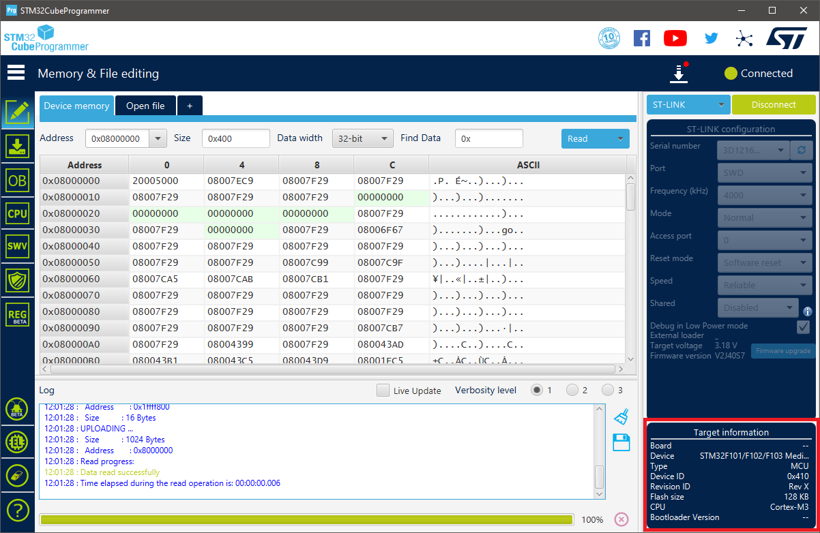

Figure 2‑2. The counterfeit read as an STM32F103 Medium Density device with a 128-KB Flash memory

Each Blue Pill board offers 32 input/output port pins available for use with interrupt capability, 18 of which are 5-V tolerant [7]–[9]. The STM32F103C8T6 microcontroller is built with 2 12-bit Analogue-to-Digital Converter (ADC) modules sharing 10 physical input pins (from PA0 to PA7, and PB0, PB1), 7 timers whose resolutions range from 16-bit to 24-bit, and remappable communication interfaces including I2C, U(S)ART, and SPI. As a result, the STM32F103C8T6 is determined to be able to handle communications with other devices used in this design.

## Sensor Units

In agriculture, the weather factor plays a key role in the growth and development of plants, since it affects both the environment (e.g., soil, fungi, pests) and the plants themselves (e.g., the integrity of branches and leaves) [10]–[12]. By monitoring the corresponding meteorological parameters, agronomy helps to predict weather events and to plan suitable adjustments to an area for the maximised agric productivity. Some such qualities includes wind data, rainfall, temperature, humidity, and atmospheric pressure, which are to be monitored by the Autonomous Wireless Agrometeorology Station via a set of sensors which are looked into in this section.

### Anemometer

The Autonomous Wireless Agrometeorology Station includes a sensor kit SP-WS02 for the Wireless Weather Station WH2081 by Misol Electronics. The kit consists of a thermo-hygrometer, an anemometer, a wind vane, and a rain gauge [13]. However, the temperature – humidity sensor is not used since it is of unknown type and encased along with the processing unit of Misol’s Weather Station. Section 3.2 therefore explores the other 3 devices, first of which is the anemometer for reading wind speed.

The anemometer follows the standard design for 3-cup anemometers, which was built to replace the traditional 4-cup design due to its superior aerodynamic performance [14], with an addition of a magnet and a reed switch. The leads of the reed switch is further extended by an RJ11 cable to allow reading of the switch electrically with a suitable circuitry.

|  |  |
| --- | --- |
| 3.85 cm  (inner) | 9.2 cm |
| 1. Side view | 1. Top view |

Figure 2‑3. The three-cup anemometer [1]

|  |  |
| --- | --- |
|  |  |
| 1. The internal reed switch shown upon   the removal of bottom cap | 1. The connection between the reed switch and the RJ11 connector [15] |

Figure 2‑4. “The internal reed switch of the anemometer” [1]

The reed switch is observed to be normally open upon removal of the PCB (Figure 2‑4a) from the sensor body. When the magnet fixed under the rotor passes, the reed switch produces a click, based on which it is found to close twice per revolution of a cup.

### Wind Vane

The second device from the sensor kit SP-WS02 is a wind vane for reading wind directions. Underneath the rotor of the wind vane is there a magnet which closes up to 2 out of 8 normally-open reed switches on the PCB inside the body of the sensor (Figure 2‑6). Each reed switch is paired with a unique resistor whose value is read to determine the position of the rudder blade, thus the wind direction.

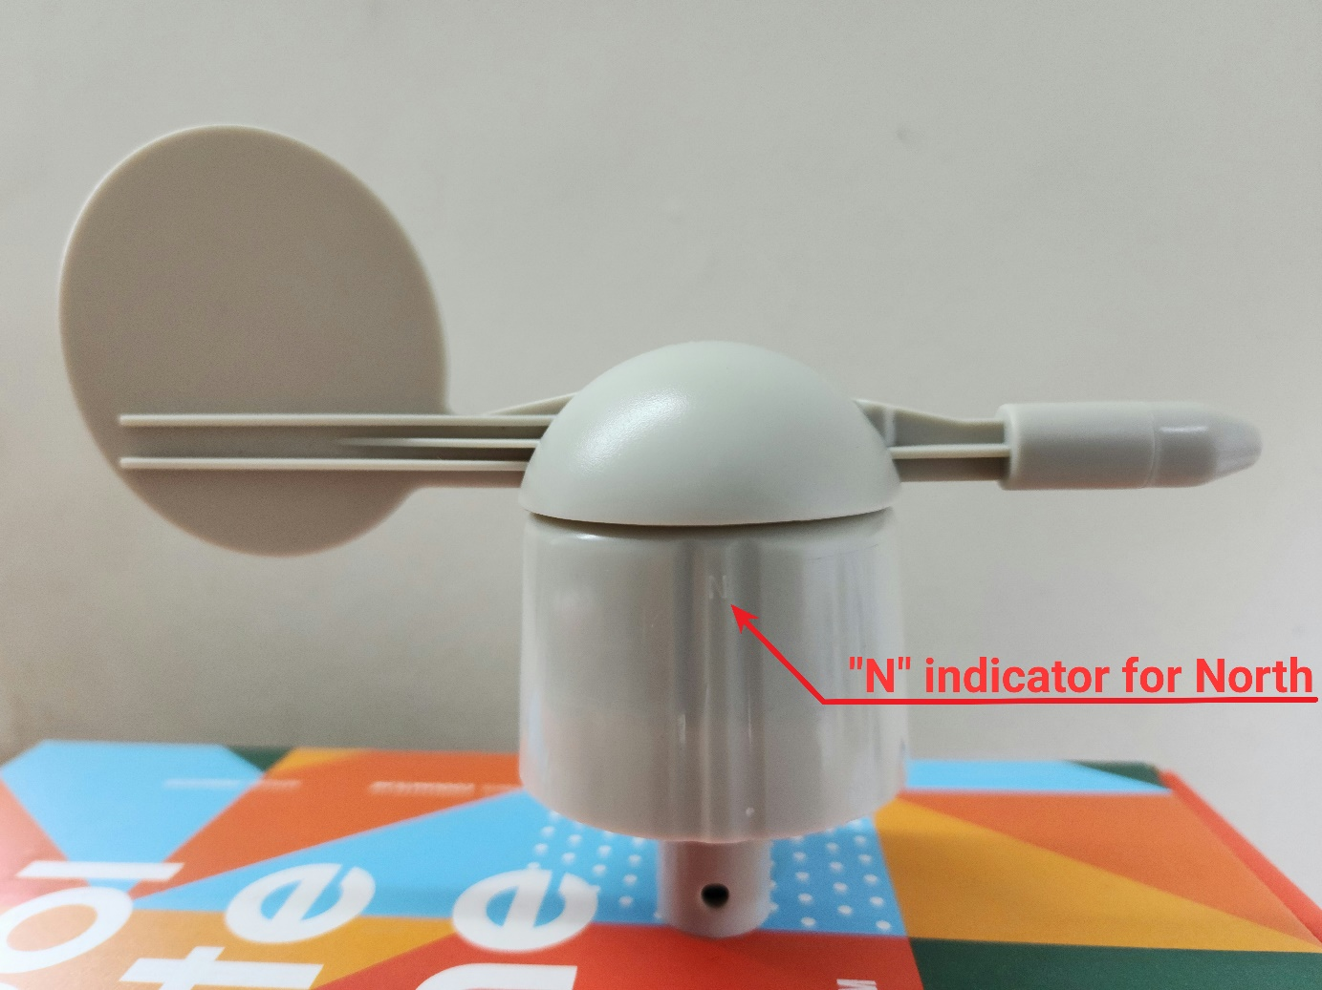

Figure 2‑5. The wind vane [1]

|  |  |
| --- | --- |
|  |  |
| 1. Reed switches inside the wind vane | 1. Schematic of the wind vane’s circuit from [15] |

Figure 2‑6. Electrical circuit of the wind vane [1]

The wind vane has an RJ11 port for users to connect the anemometer and combine the 2 sensors into 1 output via the wind vane’s RJ11 cable as illustrated in Figure 2‑6b. When set up accordingly to the 4 directions marked on the sensor’s body, the aforementioned resistors give the direction as shown in Table 2‑1. It has been pointed out that the magnet could close 2 reed switches simultaneously, thus parallel resistors formed and 8 additional wind directions to be read.

|  |  |  |  |  |  |  |  |
| --- | --- | --- | --- | --- | --- | --- | --- |
| Direction (single resistor) | | | R | Direction (parallel resistors) | | | R |
| Cardinal point | | Azimuth degrees | Cardinal point | | Azimuth degrees |
| North | N | 0˚ | 33 KΩ | North-Northeast | NNE | 22.5˚ | 6.57 KΩ |
| Northeast | NE | 45˚ | 8.2 KΩ | East-Northeast | ENE | 67.5˚ | 891 Ω |
| East | E | 90˚ | 1 KΩ | East-Southeast | ESE | 112.5˚ | 688 Ω |
| Southeast | SE | 135˚ | 2.2 KΩ | South-Southeast | SSE | 157.5˚ | 1.41 KΩ |
| South | S | 180˚ | 3.9 KΩ | South-Southwest | SSW | 202.5˚ | 3.14 KΩ |
| Southwest | SW | 225˚ | 16 KΩ | West-Southwest | WSW | 247.5˚ | 14.12 KΩ |
| West | W | 270˚ | 120 KΩ | West-Northwest | WNW | 292.5˚ | 42.12 KΩ |
| Northwest | NW | 315˚ | 64.9 KΩ | North-Northwest | NNW | 337.5˚ | 21.88 KΩ |

Table 2‑1. Wind directions by resistor values [15]

Table 2‑1 data is given by Argent Data Systems and verified by the use of a multimeter. In a microcontroller-based system, reading resistor value, thus the wind direction, from the wind vane could be done by mimicking the behaviour of a multimeter in resistance measurement mode: injecting a constant current to get a voltage across the internal resistors [16]. Another approach is to use an external resistor to form a voltage divider [15]. Either way, the resistive value accoss the RJ11 inductors of the wind vane must be determined by an ADC module.

|  |  |
| --- | --- |
|  |  |
| 1. Current mirror circuit as  a constant current source | 1. Voltage divider with an external resistor |

Figure 2‑7. Examples of wind vane-reading circuits

### Rain Gauge

The third device from the sensor kit SP-WS02 used in this project is a rain gauge as a self-emptying tipping bucket. It is comprised of 2 small buckets mounted on a fulcrum like a seesaw underneath a funnel (Figure 2‑8). The design allows the buckets to tip over a side when one is full to be emptied through the opennings on the base of the rain gauge, while the other in turn collects rain water. The magnet fixed to the bucket (Figure 2‑8b), on the other hand, also moves pass the reed switch hidden inside the case on the rain gauge base and momentarily closes it. Since the reed switch leads are extended via an RJ11 cable, with a suitable circuitry, electrical pulses could be generated and read by the microcontroller.

|  |  |
| --- | --- |
|  |  |
| 1. Top view: the orifice of the funnel | 1. Disassembly: the buckets on a pivot |

Figure 2‑8. The structure of the rain gauge [1]

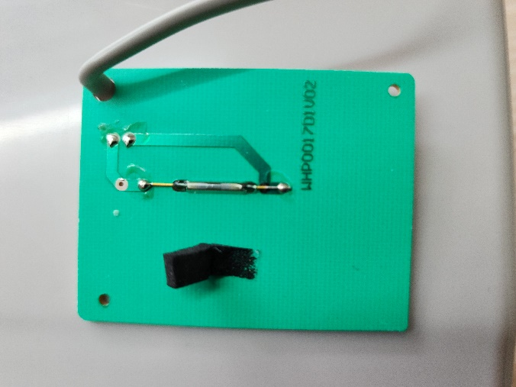

Figure 2‑9. Rain gauge’s reed switch on a PCB upon removal of base chassis cover cap [1]

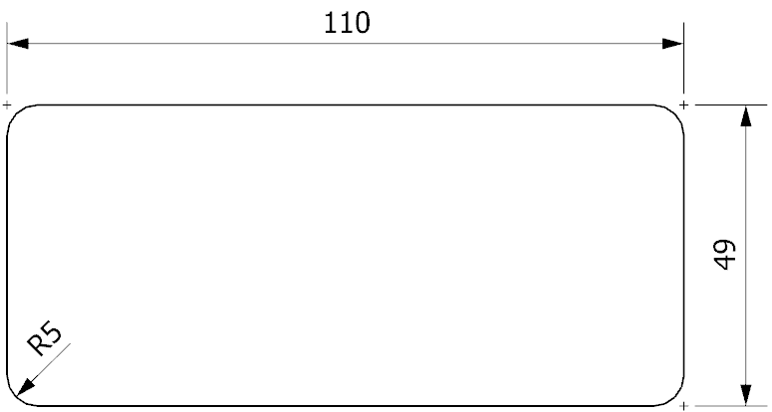

Figure 2‑10. Orifice dimensions (in mm) of the funnel [1]

Misol Electronics states that the rain gauge produces 1 pulse for every 0.3 mm of rain [17], while Argent Data System provides a value of 0.011”, or 0.2794 mm [15]. However, since the resolution provided by the latter is converted from inches, the difference may be neglected, and the value of 0.3 mm rainfall per tip could later be used to construct the software for the Autonomous Wireless Agrometeorology Station.

### BME280

BME280 is a self-calibrating environmental sensor by Bosch Sensortec GmbH. It is a combined digital sensor for barometric pressure, relative humidity, and ambient temperature, developed for multiple targets including mobile devices and wearables, thus the advantages of small size and low power consumption [18], [19]. The device in this design, arrives on a pinout board with a 2.54-mm single row header strip (Figure 2‑12) for convenience in prototyping and testing.

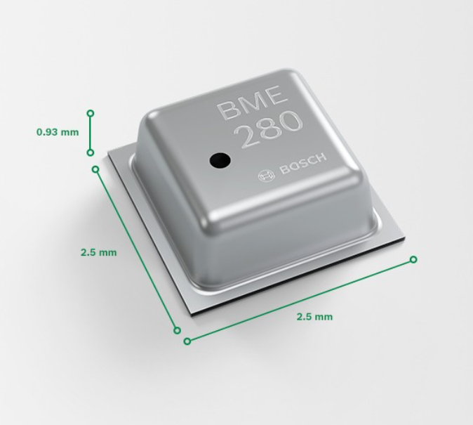

Figure 2‑11. Dimensions of a BME280 sensor [18]

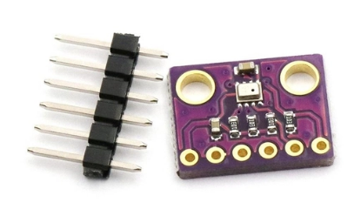

Figure 2‑12. BME280 module with header strip [20]

According to [19], the product specifications of the BME280 are as follows:

* Operational voltage: 1.71 V to 3.6 V
* Communicational voltage: 1.2 V to 3.6 V
* Typical current consumption: 0.1 µA (sleep mode) to 714 µA (pressure measurement)
* Communication interface: SPI and I2C
* Full-range output:
  + Temperature: -40 ℃ to +85 ℃
  + Humidity: 0 %RH to 100 %RH
  + Pressure: 300 hPa to 1100 hPa
* Data resolution:
  + Temperature: 0.01 ℃
  + Humidity: 0.008 %RH
  + Pressure: 0.18 hPa (minimum)
* Data accuracy:
  + Temperature: ±0.5 ℃ (0 ℃ to 65 ℃) up to ±1.5 ℃ (-40 ℃ to -20 ℃)
  + Humidity: ±3 %RH
  + Pressure: ±1 hPa

As an IC sensor, the BME280 is built with not only the sensing units but also mode control, data compensation, and noise reduction by oversampling and a digital filter. During software setup, the BME280 could be configured with the parameters shown in Table 2‑2.

|  |  |
| --- | --- |
| Parameter | Valid values |
| Sensor mode | Sleep mode, Normal mode, Forced mode |
| Pressure sampling rate | None (sampling is turned off), x1, x2, x4, x8, x16 |
| Temperature sampling rate |
| Humidity sampling rate |
| IIR filter coefficient | Off (IIR filter is turned off), x2, x4, x8, x16 |
| Standby time for normal mode (in milliseconds) | 0.5, 10, 20, 62.5, 125, 250, 500, 1000 |

Table 2‑2. BME280 setup parameters [19]

### DS18B20

DS18B20 is a family of digital temperature sensors by Maxim Integrated that follows the design of DS1820, a predecessor introduced by Dallas Semiconductor in 1998 [21]. Although the DS18B20 sensors are offered in only 3 types of packages by the manufacturer [22], a waterproof version with a long cable built from the 3-pin TO-92 configuration DS18B20 is available and has had its application explored off a PCB in different environments (e.g., liquids) [21], [23]–[25]. Because of this version, the DS18B20 is chosen to monitor the ambient temperature at ground level for this project. Although there are other choices of sensors with long cables, they either need heavily calibrating (e.g., Resistance Temperature Detector PT100 [26]), or have higher price and unnecessary functions (e.g., the AM2315 temperature and humidity sensor priced at 830,000 VND compared to the 71,000-VND DS18B20 temperature sensor with 1-m long cable [27], [28]).

|  |  |
| --- | --- |
|  |  |
| 1. TO-92 configuration | 1. Waterproof version with 1-m long cable |

Figure 2‑13. DS18B20 hardware

According to [2], the specifications of the sensor are as follows:

* Operating voltage: 3.0 V to 5.5 V
* Active current: typically, 1 mA (VDD = 5 V)
* Standby current: typically, 750 nA
* Sink current: maximum, 4.0 mA
* Full-range temperature output: -55 ℃ to +125 ℃
* Data resolution: programmable; 0.5 ℃, 0.25 ℃, 0.125 ℃, and 0.0625 ℃
* Minimum thermometer error: ±0.5 ℃ (from -10 ℃ to +85 ℃)

Communication with a DS18B20 is done asynchronously via the bi-directional One-Wire (1-Wire) protocol, which works under the principle of timing, digital input/output, and interchanging control of a single wire among masters (microcontrollers) and slaves (1-Wire devices). Although the standard communication speed is announced to be a maximum of 16.3 kbps, a high-speed mode “overdrive” of up to 90 kbps is available [29], [30]. The 1-Wire protocol allows a DS18B20 to operate not only on an external power supply but also in a parasite mode as depicted in Figure 2‑14 for lower power consumption [22]. However, it is found that the circuitry in Figure 2‑14b is only applicable if the microcontroller turns on the MOSFET before releasing the 1-Wire bus for the sensor when required. Alternatively, the MOSFET could be replaced by software (Figure 2‑14c) when the microcontroller outputs “HIGH” on its digital pin of the 1-Wire bus as soon as releasing control.

|  |  |
| --- | --- |
|  | |
| (a) DS18B20 on an external power supply | |
|  |  |
| (b) DS18B20 in parasite mode with a MOSFET | (c) DS18B20 in parasite mode  (software-controlled) |

Figure 2‑14. Circuitry examples for communication with DS18B20 [1], [22]

## SX1278 for Wireless Communication

In the design of an Autonomous Wireless Agrometeorology Station, the wireless communication between the station and a server is done via LoRa. The choice for LoRa is done from the comparison below.

|  |  |  |  |
| --- | --- | --- | --- |
| Technology | Highest data rate (uplink) | Maximum coverage | Power consumption |
| Wireless Fidelity (Wi-Fi) | 93.38 Mbps | 90 m | Medium to high |
| Bluetooth | 1 – 3 Mbps | 100 m | Low |
| Cellular network | 18.27 Mbps | Several kilometres | Medium to high |
| LoRa | 37.5 kbps | Several kilometres | Low |
| Zigbee | 250 kbps | 50 m | Low |
| Near Field Communication (NFC) | 424 kbps | 10 cm | Low |
| Radio-frequency Identification (RFID) | 424 kbps | 10 cm | Low |

Table 2‑3. Comparison of different wireless communication technologies for IoT in Vietnam [31]–[35]

It could be observed that Wi-Fi provides the highest communication speed, while data-exchange is slowest via LoRa. The data collected and transmitted by the system are just sensor readings, so the data rate does not need to be high [36].

The next criterium to be taken into account is the range over which communications are performed. LoRa and Zigbee could be seen to allow data exchange range. Despite the maximum range of 90 m, Wi-Fi signals could typically reach a maximum of only 45 m [37], which should not be a problem for an agricultural application. The common Bluetooth modules HC-05 and HC-06 provide a connection up to 100 m [38], so Bluetooth remains an option. Only NFC and RFID technologies are invalid since they are applicable for only short-range communications.

In terms of power consumption, Wi-Fi and cellular network are not ideal for a self-contained off-grid design. Bluetooth, in spite of the low power consumption, is said to be more “power hungry” compared to LoRa [39]. That leaves LoRa and Zigbee the remaining choices for wireless communications.

For this project, LoRa and Zigbee are lastly compared over product prices. A major supplier in Ho Chi Minh City, Vietnam chosen for referencing is Thegioiic. The LoRa modules SX1278 are sold at around 100,000 VND, while prices for the Zigbee modules go from 183,000 VND [40], [41]. As a result, LoRa is the wireless communication technology chosen for this design, and 2 LoRa modules SX1278 are picked for the station and the server side. Each module is a PCB module with an 8-pin 2.54-mm dual row header strip for convenience in prototyping and testing.

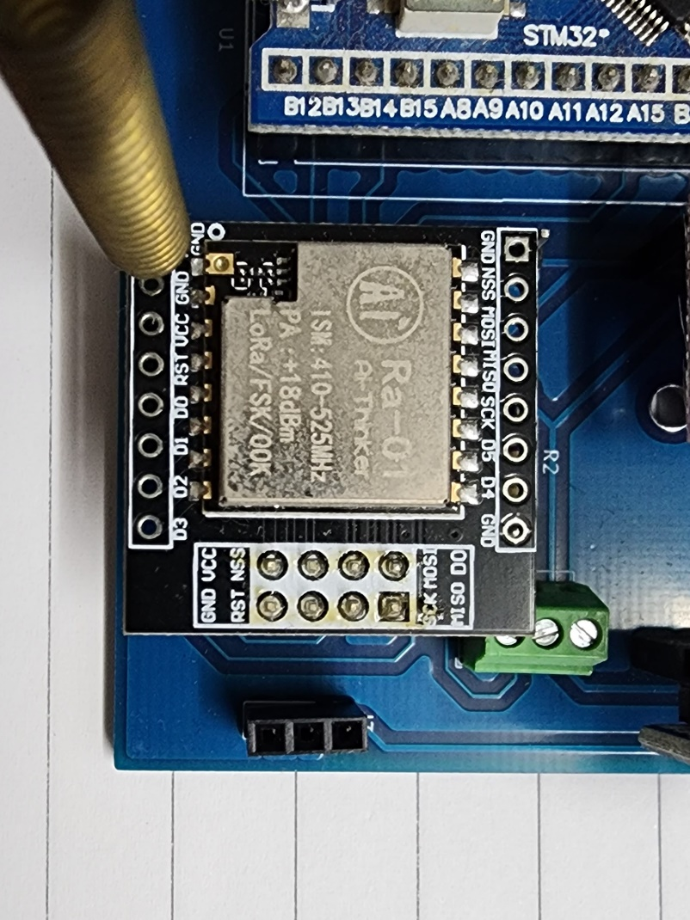

Figure 2‑15. SX1278 LoRa module in test

The product specifications for LoRa mode from [42] are as follows:

* Operating voltage: 1.8 V to 3.7 V
* Current consumption: 0.2 µA (sleep mode), up to 12 mA in receive mode or 120 mA during data transmissions
* Communication protocol: SPI
* Spreading factors: 6 to 12
* Cyclic coding rate: 4/5 to 4/8
* Signal bandwidth (in kHz): 7.8, 10.4, 15.6, 20.8, 31.2, 41.7, 62.5, 125, 250, and 500
* Package preamble length (in symbols): 6+4 to 65535+4
* User-defined package synch word: 8-bit synch word

## Other Modules

### DS3231

Time keeping is an extended feature for the Autonomous Wireless Agrometeorology Station. Although the STM32F103C8T6 microcontroller already has a built-in real-time clock (RTC), an external module is explored for higher precision of time data.

The DS3231SN is an RTC from the DS3231 product lines by Maxim Integrated, clocked at 32,768-Hz by an internal crystal. Another member from the DS3231 product lines is the DS3231M. A major difference between DS3231SN and DS3231M is that the former is built with a temperature-compensated crystal oscillator (TCXO) for the improved quality of time keeping [43], which could be checked via its 32K pin. As a result, the accuracy is proven to be much higher than that of the DS3231M [44]. For testing purposes, a DS3231SN pinout module (Figure 2‑16) is in use.

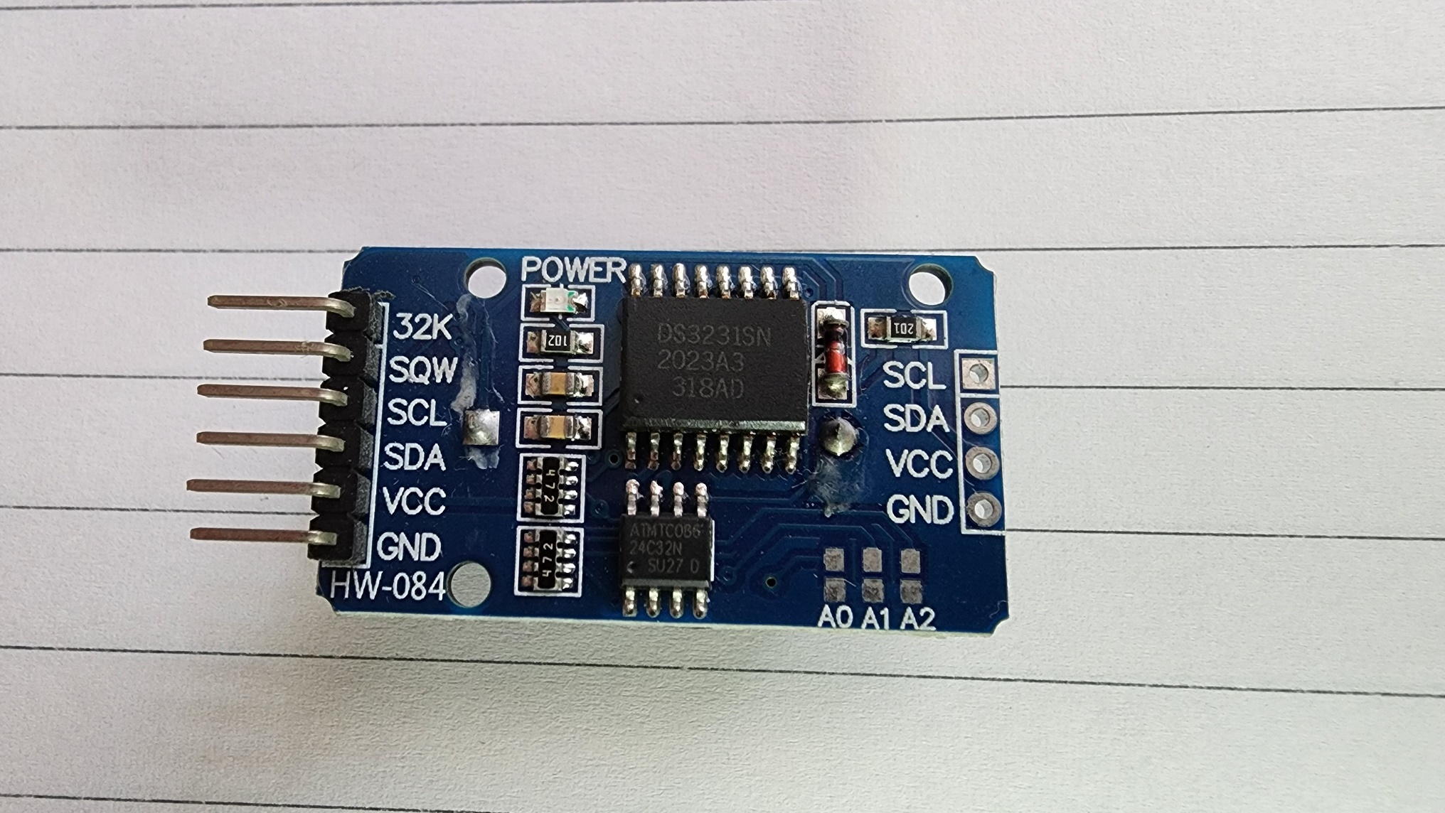

Figure 2‑16. DS3231SN pinout module

The key specifications of the DS3231SN from [45] are as follows:

* Operating voltage: 2.3 V to 5.5 V
* Battery voltage: 2.3 V to 5.5 V
* Maximum active current: 200 µA at 3.63 V
* Maximum standby current: 110 µA at 3.63 V
* Typical standby current from battery: 0.84 µA
* Effective time keeping range: from 1970 to 2100
* Compensated base clock output on 32kHz pin
* Programmable square wave output or alarm on pin
* I2C communication interface at up to 400 kHz

### microSD Card

### Analogue Low-pass Filter (LPF)

Any real-life systems are always faced with the noise problem which roots from various sources like external interference or the components of the system itself [46], [47]. Producing clean electrical signals to use in an application although is not possible, reducing the effects of noise to reach a such goal remains practical. Since noise are usually unwanted high frequency signals injected into the desired ones, the method of using analogue filters could be applied. The simpliest form of LPFs against noise is a passive first-order RC LPF as demonstrated in Figure 2‑17.

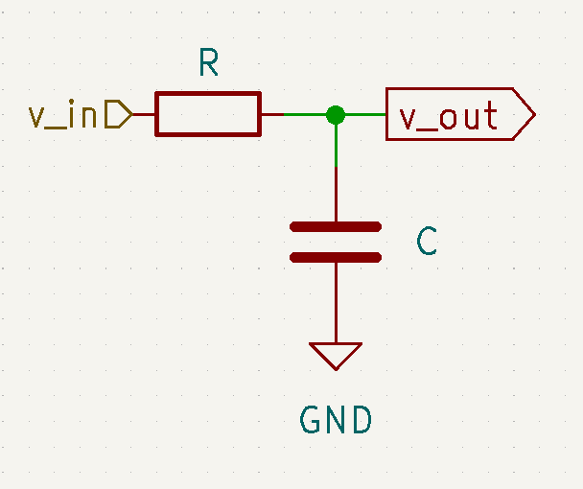

Figure 2‑17. Passive first-order RC LPF circuit

The circuit above acts under the principle of a voltage divider:

$\frac{v_out}{v_in}=\frac{Z_{C}}{Z}=\frac{Z_{C}}{\sqrt{R^{2}+Z_{C}^{2}}}$, where $Z_{C}=\frac{1}{2πfC}$ and $f$ is the frequency of the input signal $v_in$.

The cut-off frequency $f_{c}$ of a LPF is defined to be the frequency at which the voltage gain on the logarithmic scale of the output $A_{V}=20×log⁡(\frac{v_{out}}{v_{in}})$ is -3 dB [48], or $\frac{v_out}{v_in}=\frac{1}{\sqrt{2}}$. As the result, the cut-off frequency of a passive RC LPF is $f_{c}=\frac{1}{2πRC}$. For example, a LPF with $R = 1 kΩ$ and $C = 100 nF$ has the cut-off frequency $fc = 1591.55 Hz$.

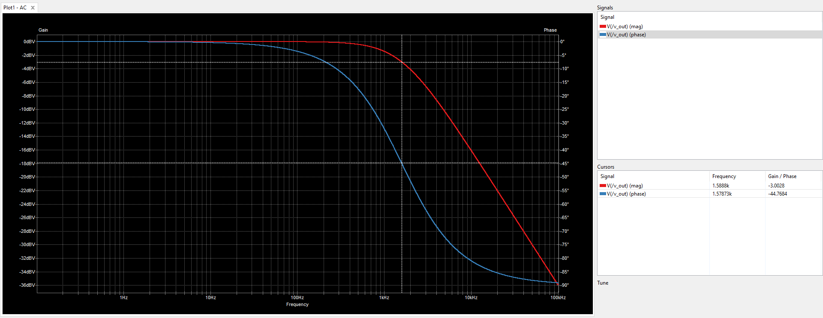

Figure 2‑18. Frequency response of an example RC LPF with $R = 1 kΩ$ and $C = 100 nF$ under simulation [1]

## System Powering

One of the requirements for the Autonomous Wireless Agrometeorology Station is that it is able to operate off-grid. In order to do that, the system needs another power source. Some possible solutions are solar power, wind energy, and replaceable batteries.

For a system running solely on batteries, there arise some potential issues:

* System downtime during battery replacement, or when the batteries are drained,
* Requirement to constantly monitor the battery voltage to alarm an operator in case replacement is in place,
* Difficulty in approaching the station site during extreme weathers like rains or storms,
* And availability of a human operator.

The quality of meteorological monitoring depends heavily on the uptime of the sensor node, so the potential downtime rules out the battery solution.

Wind and sun are among the renewable power sources, and have high availability. Ideally, the sensor station is installed on an open field, so access to these power sources is not difficult. However, solar energy cannot be harvested at night, while wind energy requires the use of wind turbines that are usually bulky. Out of the two, the solar power solution appears to be a better option by including a battery unit to overcome its forementioned disadvantage.

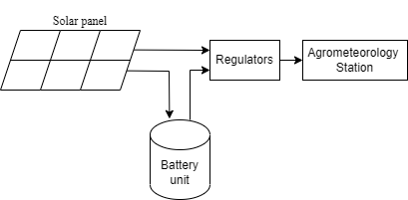

Figure 2‑19. Concept of the solar powering system

## Server

The server side for the Autonomous Wireless Agrometeorology Station consists of:

* A gateway that receives the sensor data wirelessly from the station via LoRa communication,
* And an online database which the gateway forwards the sensor data to and makes the data accessible for users.

The main idea is to involve another microcontroller to use with an SX1278 LoRa module as the gateway. The microcontroller should be able then to connect to the Internet to upload the received data to the online database of choice.

For the sake of simplicity, a nodeMCU ESP8266 is utilised because of its Wi-Fi connection capability and its availability, as well as the Arduino framework for software development. The online database of choice is ThingSpeak by The MathWorks Incorporation, on top of services like Microsoft Azure, Google Firebase, and InfluxDB.

Initially, InfluxDB was in use as the online database for the Autonomous Wireless Agrometeorology Station and proved to be intuitive [1]. However, it is discovered that this service only retains uploaded data for 30 days for free accounts, which makes it less ideal for a project of a bachelor thesis. Microsoft Azure and Google Firebase, on the other hand, offer decently free services, but the connection proccesses are quite complicated, thus ruled out. ThingSpeak is the remaining option whose service is free of charge while letting users accessing and handling data without a time limit. The only known downside of ThingSpeak is that each free account is only allowed 4 data channels, which is not an issue in testing and prototyping the Autonomous Wireless Agrometeorology Station.

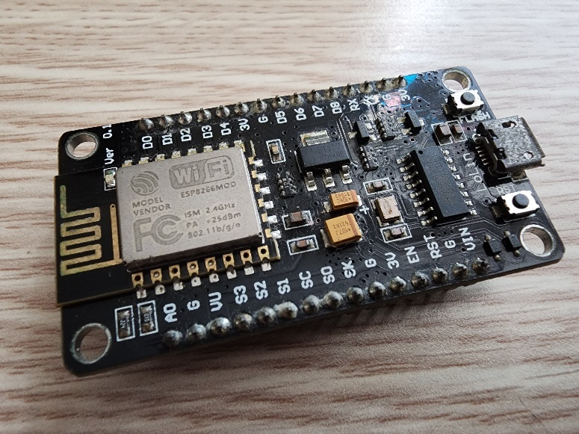

Figure 2‑20. The nodeMCU ESP8266 used at the server side of the project [1]

# Implementation

## STM32F103C8T6 Microcontroller

As mentioned in section 3.1, the STM32F103C8T6 microcontroller in test is shipped on a Blue Pill board () with all the necessary components for its peripherals. However, the implementation in this thesis does not require some included blocks such as the RTC or the voltage regulator, thus some unused hardware pins and/or components. As a result, some parts are removed from the Blue Pill board for testing purpose; and later on, the board is redesigned following Figure 4‑2. The board is then implemented with all the connections shown in Figure 4‑3.

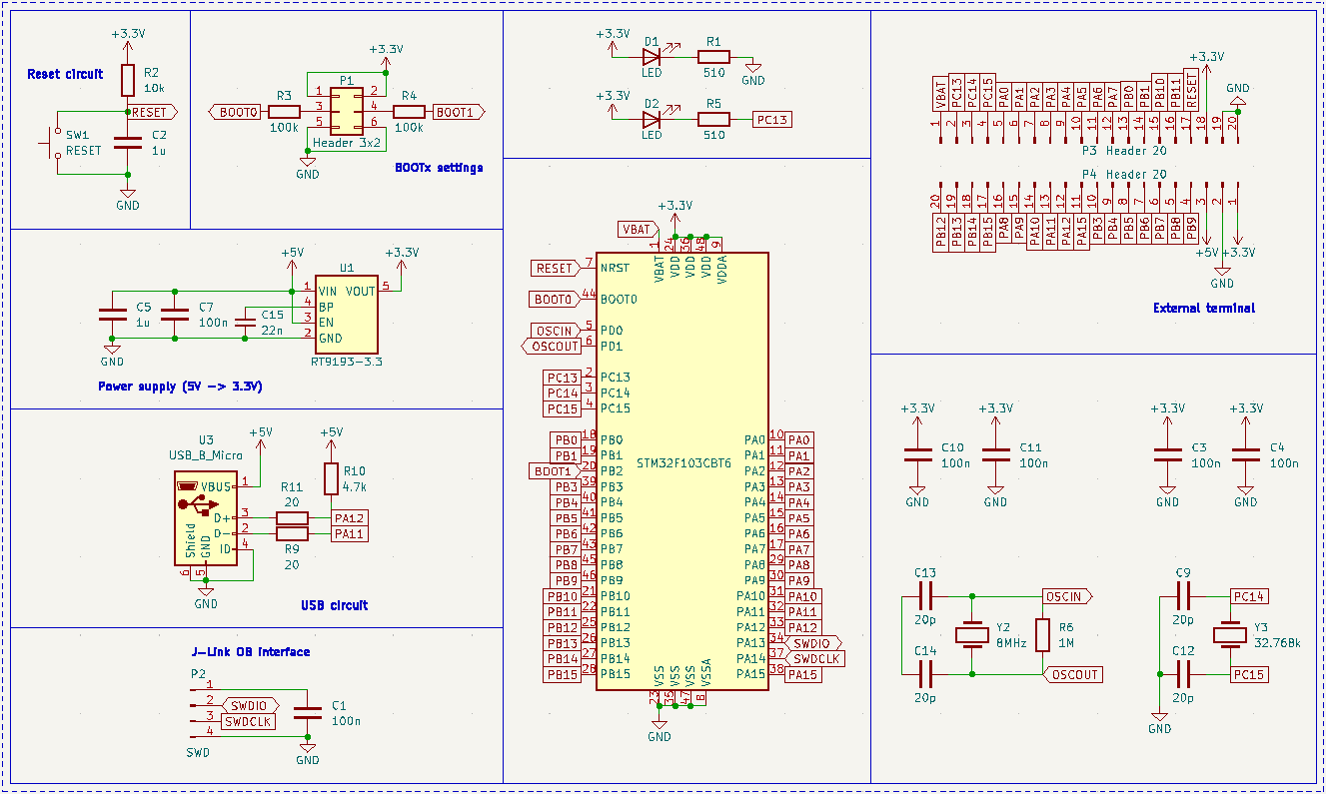

Figure 4‑1. The schematic of the STM32F103C8T6-housed Blue Pill board [7]

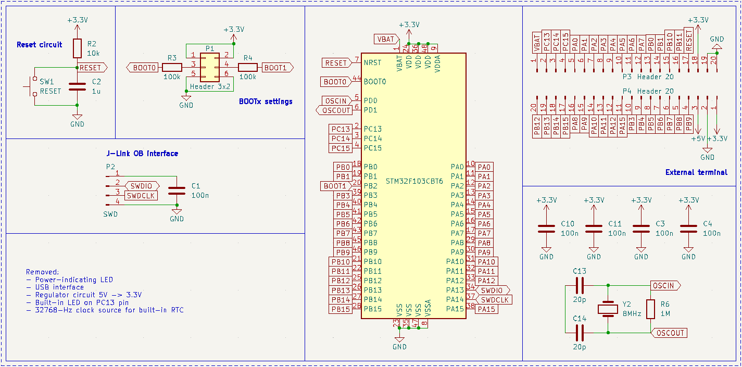

Figure 4‑2. Simplified Blue Pill schematic with removed unused parts

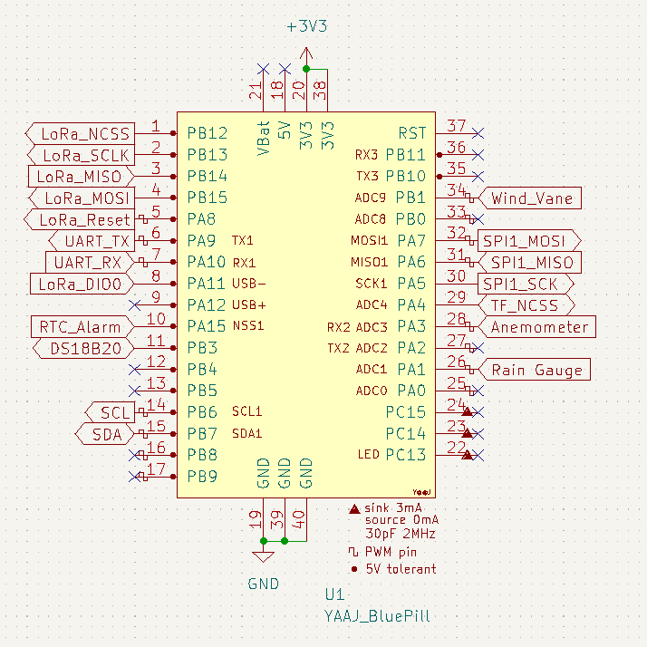

Figure 4‑3. Bus connections with the Blue Pill board

## Sensor units

### Anemometer

#### Hardware dependencies

##### Pull-up resistor

As mentioned in Section 3.2.1, the anemometer could be read through the inner 2 conductors of its RJ11 cable. If it is connected to the wind vane as shown in section 3.2.2, interfacing through the inner 2 conductors of wind vane’s RJ11 cable is done instead. It is known that the electronic part of the anemometer is a mechanical device called the reed switch. As a standalone device, a reed switch does not create any electrical signals to be read, thus the use of a setup as simple as illustrated in Figure 4‑4.

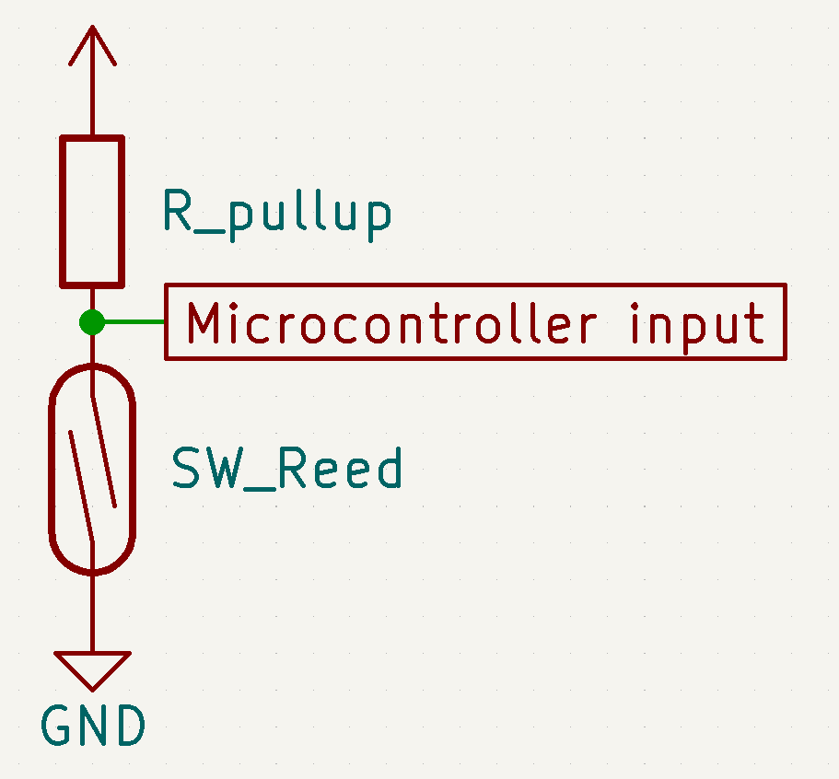

Figure 4‑4. Circuitry for testing the anemometer in ideal conditions

The circuitry in Figure 4‑4 generates active-LOW outputs by the use of the pull-up resistor, which means the microcontroller normally reads logic 1 and detects a logic 0 when the switch closes. Active-HIGH outputs could be achieved by switching the positions of the reed switch (SW_Reed) and the resistor (R_pullup); however, since there are potentially faults due to interference while the microcontroller detects logic 1 in that setup, active-HIGH signals are undesirable in this project.

The pull-up resistor value could be chosen for either strong or weak pull-up purpose. A resistor with a high value creates a weak pull-up which results in lower power consumption, and vice versa [49]. If the input impedance on the microcontroller pin is unknown, it is safe to choose a strong pull-up resistor (i.e. 4.7kΩ). However, [9] specifies that a resistor from 30kΩ to 50kΩ could be used to achieve a weak pull-up for an STM32F103CBT6 microcontroller, so the value of 33kΩ is chosen in this project. As a result, the design would be more suitable as a battery-powered application.

##### Bypass capacitor

In [1], [50], it is investigated that as a mechanical switch, a reed switch could produce noise spikes which yield wrong edge detections by a microcontroller, thus wrong data. For example, Figure 4‑5 illustrates a noise instance which could make a microcontroller read 3 falling edges instead of an expected 1 edge within a window of 98.98µs.

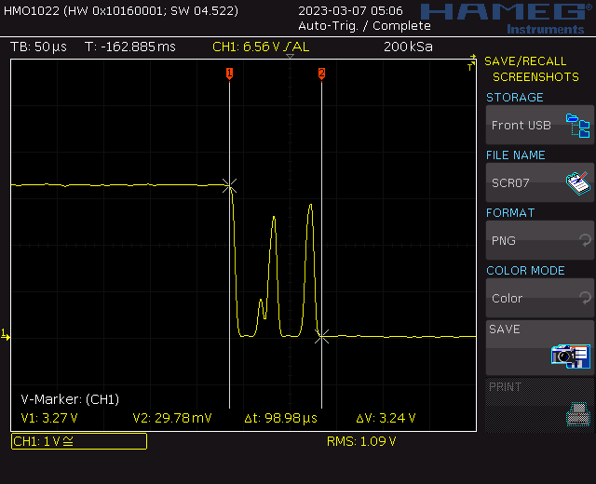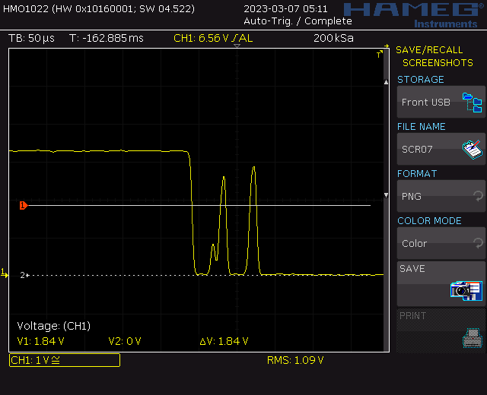

Figure 4‑5. “An instance of noise spikes captured in an oscilloscope” [1]

The solution to a such problem is the implementation of either a LPF to filter out the noise [50] or just a bypass capacitor to debounce the switch. Due to lower edge rise and fall time, and less components involved, the latter is a more preferable method [1]. The choice for a such capacitor is to satisfy that the time constant of the pull-up resistor – bypass capacitor pair is about half of the debouncing time [51].

|  |  |
| --- | --- |
| $T=R ×C$ where | $T$ (in seconds) is the time constant of the resistor – capacitor pair, |
| $R$ (in Ohms) is the value of the pull-up resistor of the switch circuit, |
| $C$ (in Farads) is the value of the decoupling capacitor. |

It is studied that reed switches have bounces up to 4.5ms. Moreover, the pull-up resistor for interfacing the anemometer with the microcontroller is chosen to be 33kΩ. Therefore, the value of the bypass capacitor is $C= \frac{T}{R} = \frac{{4.5ms}/2}{33kΩ}=68.18nF$. Since a such value does not exist in real life, the closest value of 68nF is chosen for the bypass capacitor instead.

Furthermore, the fact that the pull-up resistor is determined to be 33kΩ relies on the calculation of the bypass capacitor in this part. The bypass capacitor value is derived from a list of manufactored resistor values, which should be available for both testing and prototyping when this thesis is conducted, and is picked from the closest real numbers for a capacitor. Table 4‑1 shows that the resistor – capacitor pair of 33kΩ – 68nF fits the theoratical calculation the most.

|  |  |  |
| --- | --- | --- |
| Real resistor value | Calculated capacitor value | Closest real capacitor value |
| 30kΩ | 75.00nF | 82nF |
| 33kΩ | 68.18nF | 68nF |
| 36kΩ | 62.50nF | 68nF |
| 39kΩ | 57.69nF | 56nF |
| 47kΩ | 47.87nF | 47nF |

Table 4‑1. Choosing bypass capacitor value based on available resistors from 30kΩ to 50kΩ

In order to determine the practicability of the pull-up resistor and the bypass capacitor, a circuit illustrated in Figure 4‑6 is put in use. The reed switch stays attached inside the anemometer and is read from the corresponding pins of the RJ11 connector. The smoothed-out transitions shown in Figure 4‑7 are consistent with the findings in [1] and indicate that the setup is applicable in a real design.

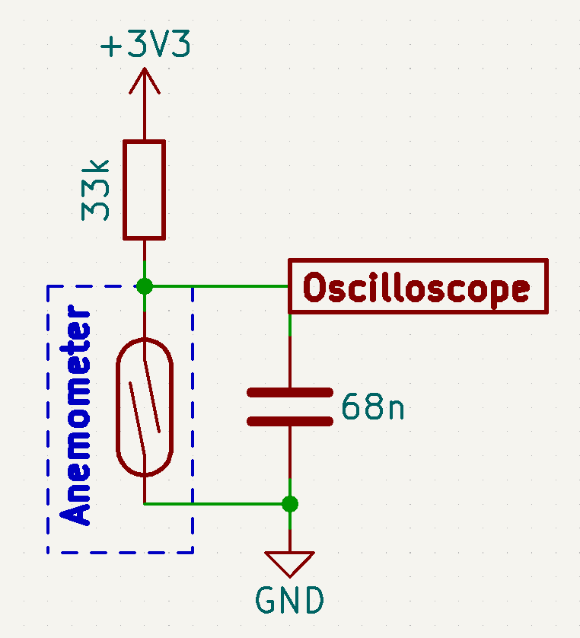

Figure 4‑6. Bypass capacitor test circuitry using the reed switch from the anemometer

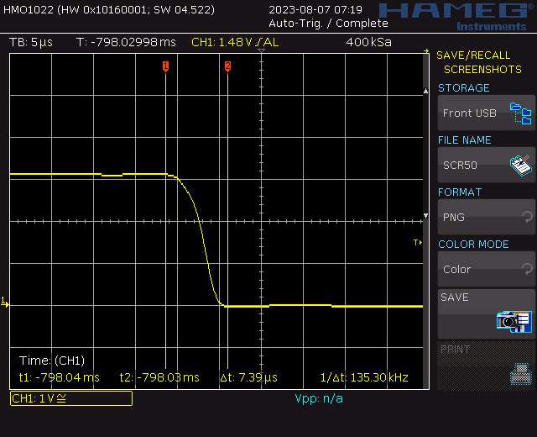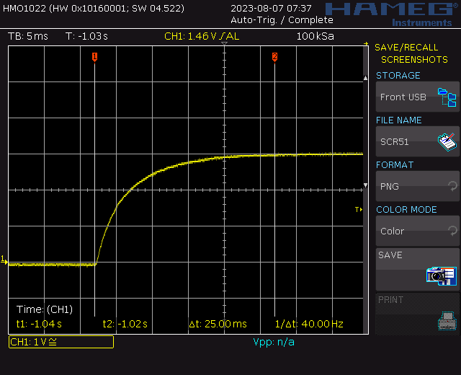

Figure 4‑7. Reed switch debounced by the 68-nF bypass capacitor

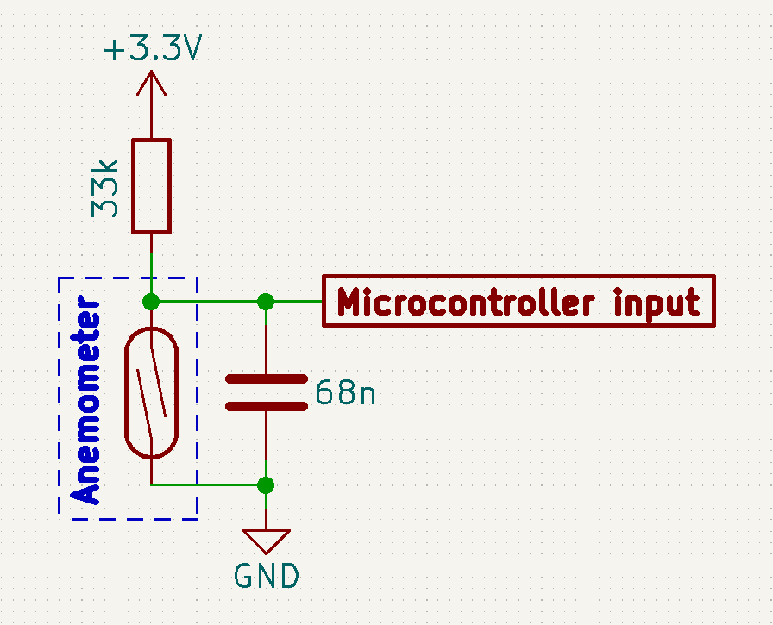

Figure 4‑8. Circuitry for interfacing with the anemometer

#### Software design

### Wind Vane

#### Hardware dependencies

##### Voltage divider

In section 3.2.2, it is illustrated that there are 2 circuitries that could be used for the wind vane: a current mirror and a voltage divider. For simplicity, the latter is utilised in this project.

In order to form a voltage divider, an external resistor as shown in Figure 2‑7b is required. The value of a such component in turn needs to satisfy that:

* Current output at the voltage divider is enough for the ADC module to charge its internal capacitor CADC for each conversion.
* Voltage step of the voltage divider values generated by all the wind vane positions is large enough for the microcontroller to distinguish.

Figure 4‑9 illustrates the voltage divider circuit when integrated with the microcontroller’s ADC module. It is assumed that at the beginning of each conversion cycle, the internal capacitor CADC has been fully discharged and the switch (“SW”) is then closed.

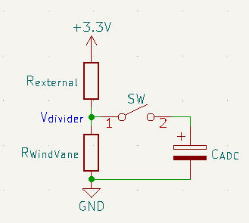

Figure 4‑9. Voltage divider circuitry with ADC module

By applying the source transformation technique, the voltage divider could be changed into a first order RC charging circuit as shown in Figure 4‑10. The Norton equivalent circuit is produced by deriving a Thévenin equivalent circuit of the +3.3V voltage source in series with the resistor *Rexternal*, which yields:

|  |  |  |
| --- | --- | --- |
|  |  | () |

The resulted circuitry is then further simplified by combining the parallel resistors into a single value:

$$R_{equivalent}=\frac{R_{external}×R_{WindVane}}{R_{external}+R_{WindVane}}$$

At this point, the step response of an RC circuit as given by [52] could be applied:

|  |  |  |
| --- | --- | --- |
|  | $$v_{C_{ADC}}=I_{S}×R_{equivalent}+\left(V_{0}-I_{S}×R_{equivalent}\right)×e^{{-t}/T}, t≥0$$ | (2) |

or, based on previously made assumption, and by substituting (3) into (2):

$$v_{C_{ADC}}=I_{S}×R_{equivalent}×(1- e^{{-t}/T}), t≥0$$

where $T=R_{equivalent}×C_{ADC}$ is the time constant for the RC circuit. It is worth noticing that the voltage up to which the capacitor CADC is charged is:

$$V_{divider}=I_{S}×R_{equivalent}=3.3V×\frac{R_{WindVane}}{R_{external}+R_{WindVane}}$$

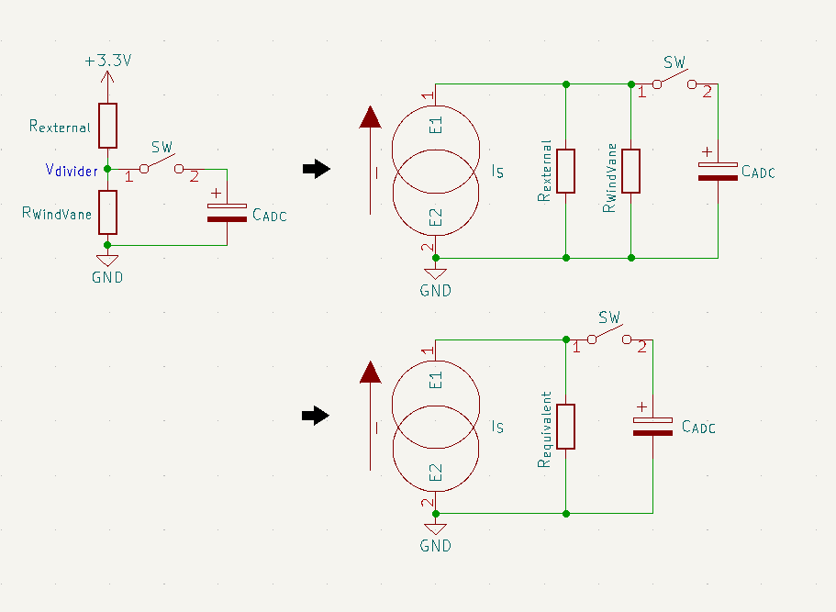

Figure 4‑10. Derivation of the Norton equivalent of the voltage divider

According to the capacitor charging voltage curve shown in [53], CADC would reach its steady state within 4*T* after the switch is closed, and become fully charged at t = 5*T*. It is desirable that the ADC internal capacitor CADC is fully charged during the sampling window of the ADC module. Since the lowest sample rate of the STM32F103C8T6 microcontroller is 1.5 ADC clock cycles [8], there holds a condition for *Rexternal*:

|  |  |  |
| --- | --- | --- |
|  |  |  |
| => |  |  |
| => |  |  |

This project uses an STM32F103CBT6 micrcontroller on the official Arduino core by STMicroelectronics, so the ADC clock frequency could be derived to be 12MHz from the core project on Github [54]. Furthermore, [9] specifies that the internal sample and hold capacitor of the ADC module is guaranteed to be 8pF by design. By substituing the wind vane internal resistance values from Table 2‑1, the condition of $R_{external}≤3.208kΩ$ is obtained. Afterward, all the manufactored resistor values which meet that condition are put into an Excel sheet to calculate the corresponding voltage step of the voltage divider with a fixed value of +3.3V power supply.

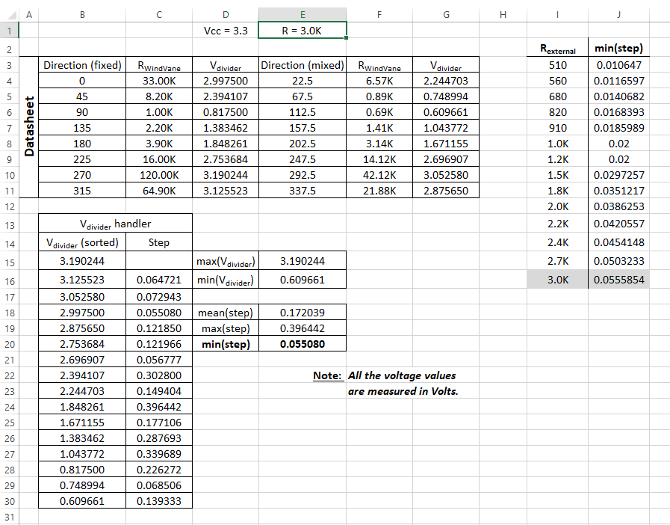

Figure 4‑11. An instance of Rexternal = 3.0kΩ input to the voltage step-calculating sheet

Table 4‑2 records all the minimum voltage steps of the voltage divider for all the resistor values under 3.208kΩ. Since the STM32F103C8T6 microcontroller has 12-bit ADC modules, in theory, it could detect analogue input changes as low as $\frac{3.3V}{2^{12}}=805.7μV$. Therefore, all voltage steps in Table 4‑2 is detectable. However, in practice, there are a number of factors like ADC offset errors, input noise, imprecise analogue reference, etc. that could cause unpredictable behaviours and/or unusable data if an ADC module were applied in ideal conditions. As a result, the largest voltage step by design for an ADC module to detect is always desired, which is 0.0555854V for Rexternal = 3.0kΩ.

|  |  |
| --- | --- |
| **Rexternal (in Ohms)** | **Voltage step (in volts)** |
| 510 | 0.010647 |
| 560 | 0.0116597 |
| 680 | 0.0140682 |
| 820 | 0.0168393 |
| 910 | 0.0185989 |
| 1.0K | 0.02 |
| 1.2K | 0.02 |
| 1.5K | 0.0297257 |
| 1.8K | 0.0351217 |
| 2.0K | 0.0386253 |
| 2.2K | 0.0420557 |
| 2.4K | 0.0454148 |
| 2.7K | 0.0503233 |
| 3.0K | 0.0555854 |

Table 4‑2. Voltage steps of the voltage divider by Rexternal

##### Low-pass filter

It has been mentioned that ADC readings could be different from expected due to input noise, which is inevitable. However, the effects of those unwanted fluctuations could first be reduced by the use of an analogue filter. Since noise is usually high frequency signals, the use of an analogue LPF is desired.

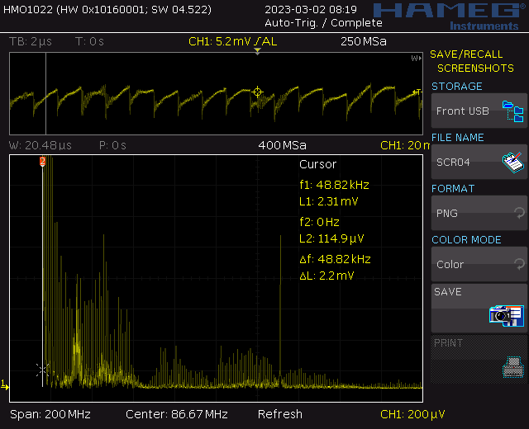

Figure 4‑12. “A noise instance captured during a test on the wind vane” [1]

Designing a LPF firstly requires the cut-off frequency. In order to achieve the best possible ADC accuracy, it is predetermined that the software for reading the wind vane shall utilise the ADC module at the highest sampling time of 239.5 ADC clock cycles [8]. The reviewed STM32duino firmware for the STM32F103C8T6 microcontroller, combined with the reference manual [8] and the STM32CubeMX, gives the ADC clock of 12MHz and the sampling frequency for the 239.5-cycle sampling time of $\frac{12MHz}{(235.9+12.5) cycles}=47.619kHz$ [54]. Furthermore, [55] states that the sampling frequency should range from 2 to 5 times the frequency limit of the input signal, which results in the cut-off frequency by the LPF to be between 9.524kHz and 23.810kHz. The such frequency band is then narrowed down to 9.524kHz – 12.62kHz since the latter was observed to be the lowest noise signal when the test for Figure 4‑12 was conducted.

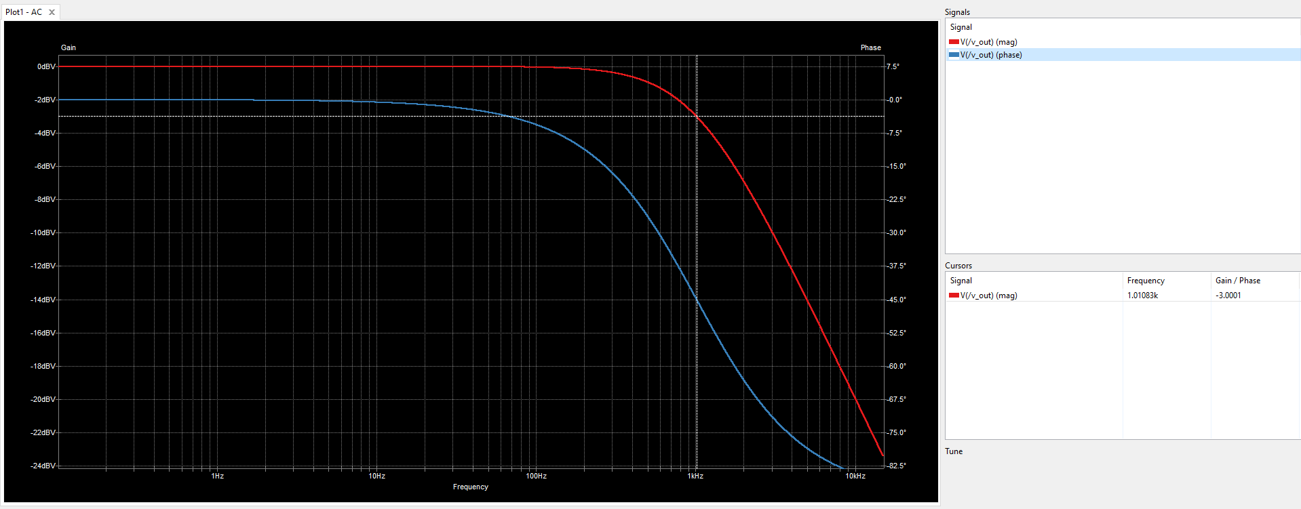

Figure 4‑13. Frequency response of the 1.013-kHz RC LPF

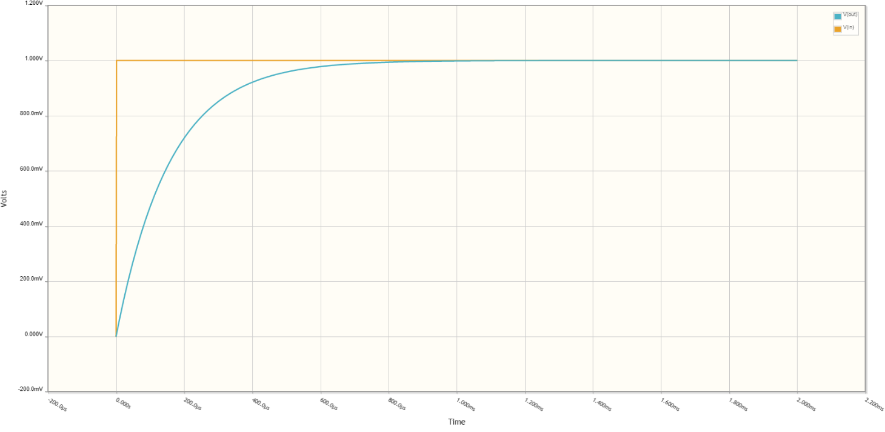

Figure 4‑14. Step response of the 1.013-kHz RC LPF

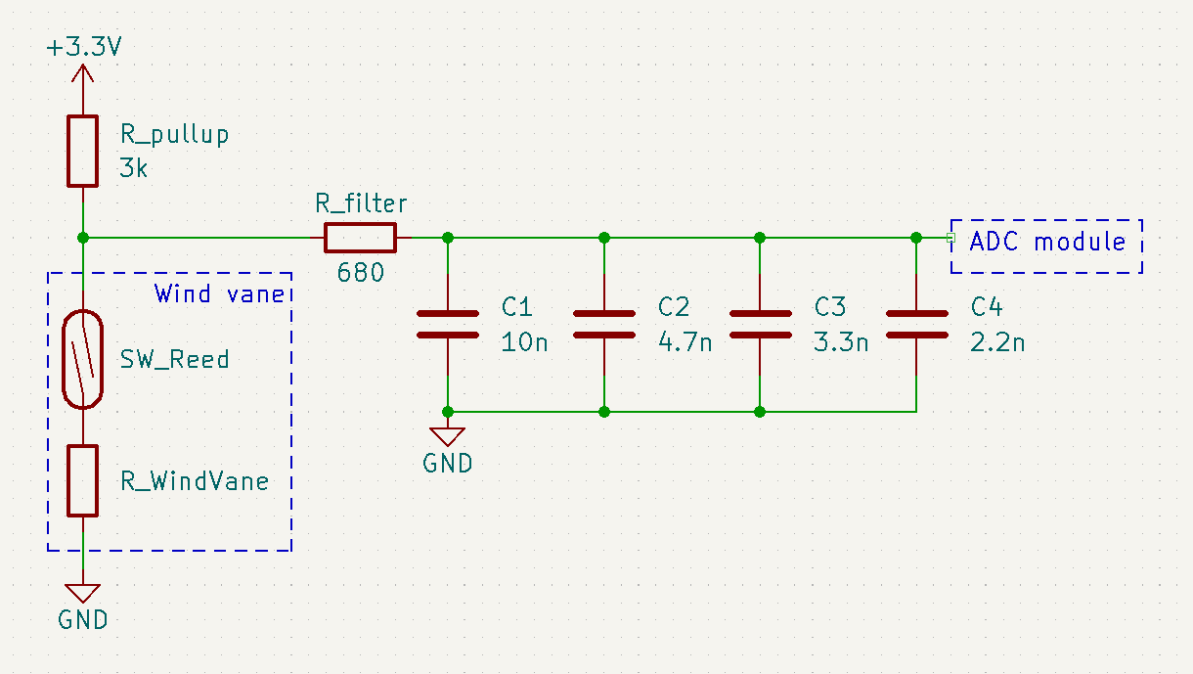

Figure 4‑15. Circuitry for reading the wind vane

#### Software design

### Rain Gauge

#### Hardware design

Since the electrical parts of the rain gauge and the anemometer are essentially the same, the exact circuitry for the anemometer could be used for the rain gauge.

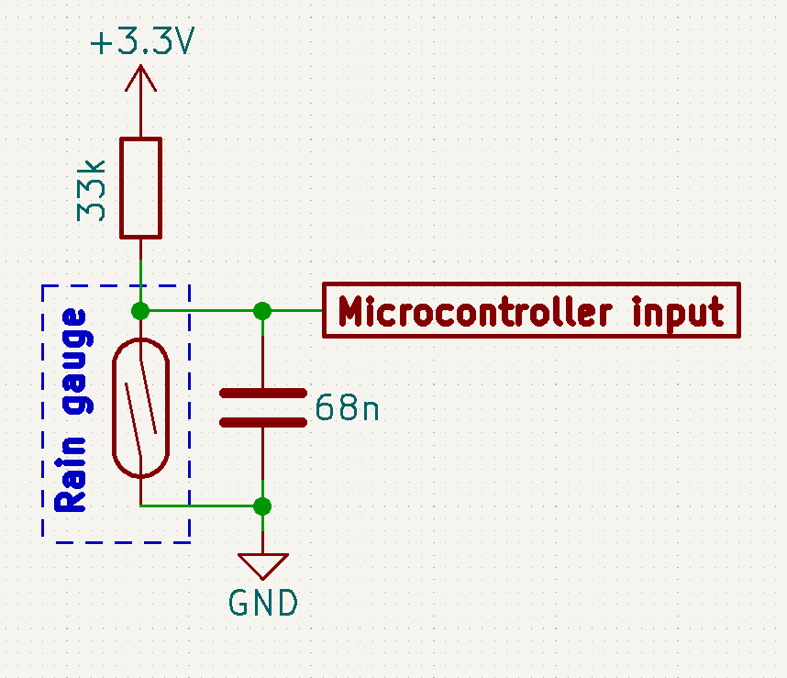

Figure 4‑16. Circuitry for interfacing with the rain gauge

#### Software design

### BME280

#### Hardware design

The BME280 is designed with 2 communication interfaces, SPI and I2C, configurable via the shared 4 pins, CSB, SDI, SCK, and SDO [19]. Although the STM32F103C8T6 microcontroller has 2 SPIs, both are reserved for other modules. Moreover, while the number of slaves on each SPI bus is limited by only the number of GPIO pins as SS pins, having multiple devices on the same bus introduces higher current consumption, thus lower communication effectiveness, particularly in low-power applications. The increased power consumption issue by more slaves also exists for I2C buses, but it would be much lower since this interface addresses the slaves by software [56]. As a result, the I2C interface is utilised for BME280 in this thesis.

According to [19], the BME280 is put into I2C mode by keeping the CSB pin “HIGH” at VDDIO; while the SDO pin is pulled either “HIGH” or “LOW” by direct wirings to VDDIO or GND respectively to set the I2C address to 0x77 or 0x76. Since the Arduino library for BME280 chooses 0x76 as the default I2C address for the sensor [57], this thesis designs the hardware as such.

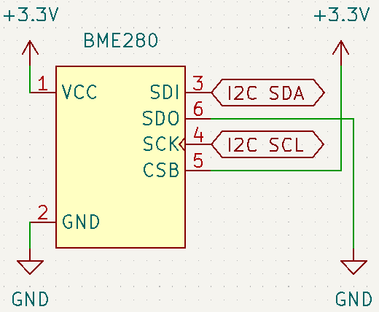

Figure 4‑17. BME280 setup for the I2C protocol

#### Software design

### DS18B20

In Section 3.2.5, it is shown that a DS18B20 could operate in 2 modes: parasite and local power modes. Due to potential issues caused by software timing and/or electrical delays [1], in this thesis, the implemented DS18B20 temperature sensor shall be powered with an external supply.

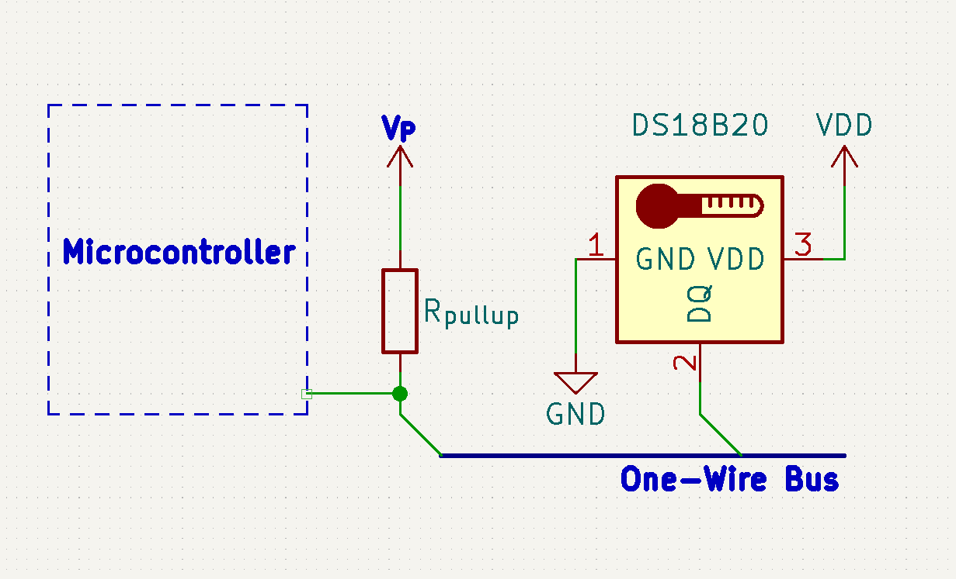

Figure 4‑18. The concept of a DS18B20 powered via an external power supply VP

Given that the DS18B20 communicates via 1-wire protocol, [58] provides the formula to calculate the available current on the bus as

$$I_{avail}=\frac{V_{pullup}-V_{pullup_min}}{R_{pullup}}$$

thus the value for the pull-up resistor for the 1-wire bus

$$R_{pullup}=\frac{V_{pullup}-V_{pullup_min}}{I_{avail}}$$

Since the DS18B20 is externally powered, the active current ID is provided directly in the Vdd pin, which leaves the “extra power demand” dependent on the input current of the data pin DQ [58]. Maxim Integrated specifies the DQ input current IDQ to be typically 5µA, and the minimum pullup supply voltage to be 3V [22]. The power supply for the DS18B20 is also the 3.3-V supply for the station, which yields the pull-up resistor to be

$$R_{pullup}=\frac{V_{pullup}-V_{pullup_min}}{I_{avail}}=\frac{3.3V-3V}{5μA}=60kΩ$$

It is worth noticing that the given DQ input current is the necessary amount for data exchange to be successful, so it could go higher than 5µA but not lower. As a result, the calculated 60-kΩ pullup resistor is the maximum value to achieve 1-wire communication between the microcontroller and the DS18B20 temperature sensor. Since there shall be no other 1-wire devices included in this design, and the active current ID does not contributes in local power mode, the suggested value of 4.7 kΩ for the pullup resistor could be used freely, thus implemented in the design for the Autonomous Wireless Meteorology Station.

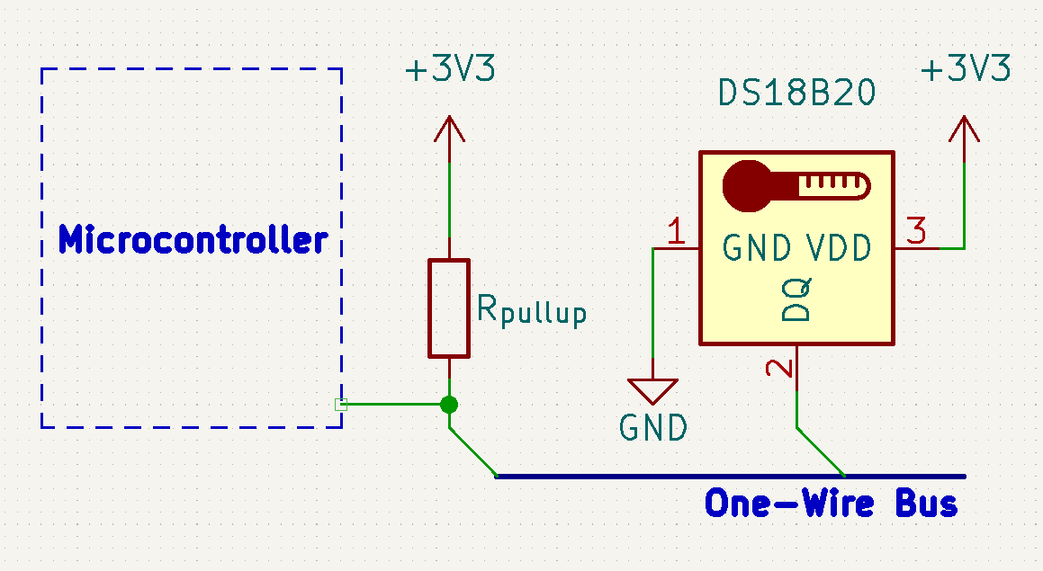

Figure 4‑19. Final circuitry for interfacing the DS18B20 with the microcontroller

## SX1278

Since this design makes use of SX1278 pinout module, further circuitries are not necessary to establish hardware connections. On the design of the Autonomous Wireless Agrometeorology Station, all the communication and control pins of the LoRa module could be connected directly to the corresponding pins of the STM32F103C8T6 microcontroller because of the similar 3.3-V logic level. If the microcontroller and the LoRa module share a voltage regulator as power source, there may be occasions when the latter puts stress on the regulator by drawing too much current during a transmission, resulting in unexpected behaviours like sudden voltage drops and undesired resets, or even damages to other components and devices. In order to prevent such issues, a separate voltage regulator is setup for the SX1278 LoRa module.

Apart from the SPI connections, the SX1278 LoRa module requires 2 more pins from the microcontroller for interrupts and resets. The interrupt pin is controlled by the module to inform the microcontroller of incoming data communication, while the LoRa_Reset signal line is required and controlled by software. The hardware connections are the same between the server side and the sensor station.

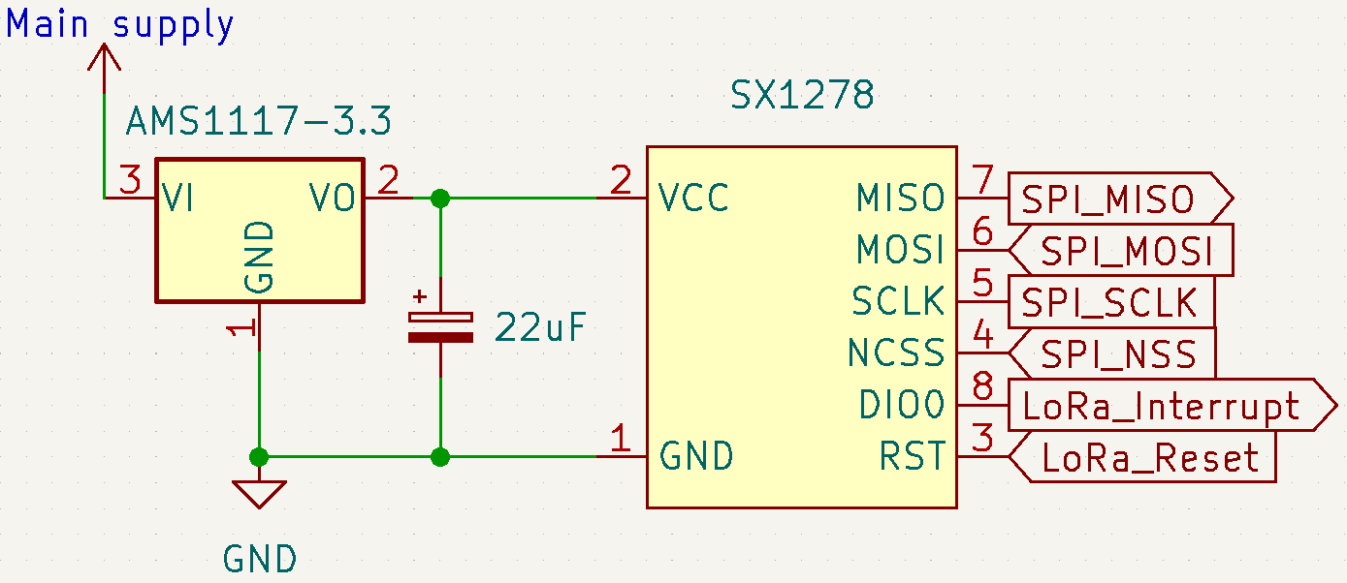

Figure 4‑20. Hardware setup for SX1278 LoRa module

## Other Modules

### DS3231SN

Since the DS3231SN pinout module contains all the necessary components for the RTC IC, there is no need for further circuitries. It does not matter whether the DS3231SN is powered at 3.3 V or 5 V, since the I2C pins of the STM32F103C8T6 microcontroller are 5-V tolerant [9]. However, if the RTC module is powered at 5 V, the minimum logic “HIGH” input is $0.7×\left(5 V\right)=3.5 V$, which is higher than the logic level of the microcontroller. Furthermore, sharing the I2C bus is another device with the maximum input/output voltage of 3.6 V, the BME280 sensor [19], 5-V power supply is not ideal for integrating the DS3231SN with the system. Therefore, the RTC module is to be powered at 3.3 V, and the backup battery is chosen to be a non-rechargeable CR2032. The removal of either the 1N4148 or the 200-Ω resistor is not necessary in this setup since the difference between power supply and the battery voltage $\left|3.3 V-3 V\right|=0.3 V$ is not enough for the diode to conduct and damage the battery.

Since some other modules work with the alarms from the DS3231SN, which is further investigated in section **Error! Reference source not found.**, the SQW of the RTC module is connected to an interrupt input of the microcontroller under a signal named $RTC_Alarm$.

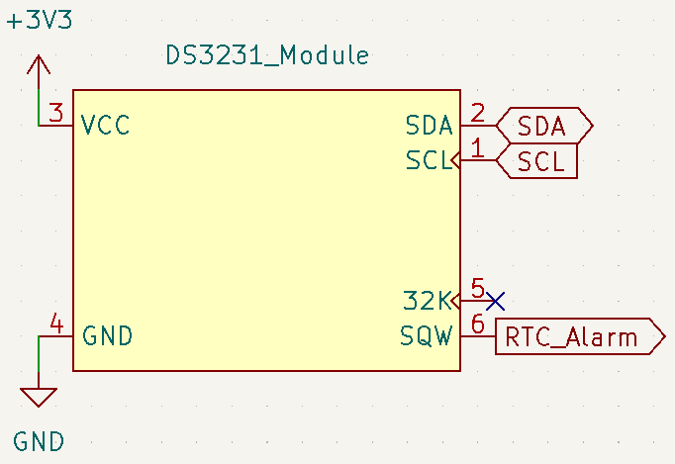

Figure 4‑21. Hardware setup with the DS3231SN RTC module

### microSD Card

## System Powering

In theory, powering a system from 2 sources simultaneously is possible if the sources are independent and produce similar voltage outputs. However, in this off-grid system, the battery unit is dependent on the photovoltaic cells to be charged. Therefore, the main system can be powered by either the solar panel or the batteries at a time.

An ideal circuit of the powering unit for the sensor station should be able to switch the sources without introducing any downtime to the sensor station. The block diagram of a such circuit is as follows.

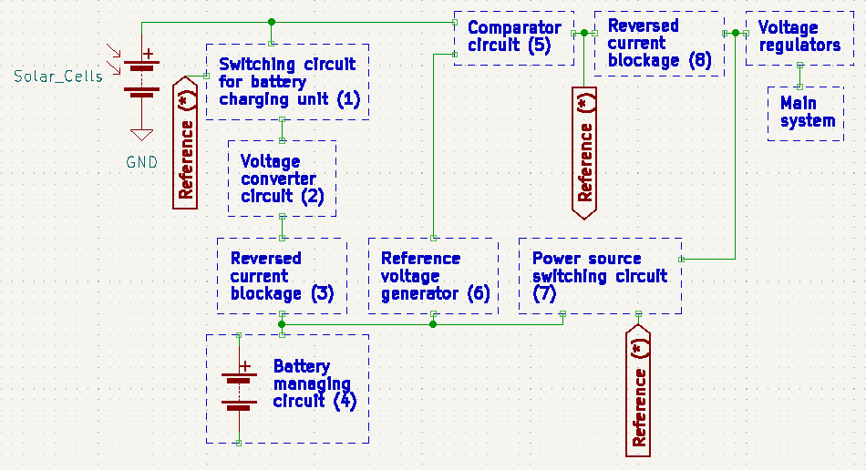

Figure 4‑22. Block diagram of the system powering circuitry

The expected operations of the circuit are divided into 3 phases:

* The solar panel charges the batteries and powers the main system simultaneously when it produces a voltage above the charging voltage of the batteries.
* The solar panel only powers the main system when it produces a voltage above the minimum input voltage of the voltage regulators, but below the charging voltage of the batteries.
* The solar panel is electrically disconnected when it outputs a voltage below the minimum input for the voltage regulators; the batteries take over the line and powers the main system instead.

The Reference (*) is the voltage of the solar panel injected into blocks (1) and (7). In the first phase, Reference (*) enables block (1), allowing a current flow into block (4) to charge the batteries. At the same time, Reference (*) disables block (7) whose function is to create a bridge for the battery current in a later phase. In this phase, block (6), Reference voltage generator, has the input of solar panel through blocks (1), (2), and (3), and produces a voltage reference to the comparator circuit (5); the reference by block (6), however, is lower than the direct input of the solar panel to block (5) which results in current continuing to flow from the solar panel to the main system. A side note is that block (6) must always generate a voltage equal to the minimum input voltage of the voltage regulators.

In the second phase, despite the Reference (*) enables block (1) for a current flow, block (2), Voltage converter circuit, expectedly outputs 0 V due to insufficient input voltage from the solar panel. As a result, the current from the solar panel only flows on 1 path and no longer flows toward block (4). Block (6) now has the input from the batteries, but its reference for block (5) remains lower than the solar panel voltage, so the path from the solar panel to the main system persists. In this phase, block (3) prevents the reversed current flow from the batteries to the voltage converter circuit (2), thus protection against any potential damages.

In the third phase, the reference by block (6) is greater than the input voltage of the solar panel to block (5), so block (5) disrupts the path from the solar panel to the main system. Expectedly, Reference (*) drops to 0 V and disables block (5), which makes the solar panel totally isolated. As opposed to the first phase, block (7) is enabled due to the absence of Reference (*) voltage and provides a current path from the batteries to the voltage regulators and the main system. In this phase, block (8) prevents Reference (*) from having the voltage of the batteries to mimic its behaviours in the first and second phases.

Since this remains a concept, no circuitry has been built and tested. In order to realise the idea, the components need picking and studying carefully, due the sensitive nature of voltage comparison in the concept. For the time being, 4 things that are clear are:

* The main system is expected to run at 3.3 V, so the voltage regulators should have the input of at least 3.6 V for some components. In case of AMS1117-3.3, the typical input is 3.3 V + 1.1 V = 4.4 V [59]. This voltage needs to be the output of block (6), Reference voltage generator.
* The “Reversed current blockage” blocks (3) and (8) have to have low forward voltage drops as well as low reversed leakage currents for the maximum protection of other components/blocks.
* The concept works in 3 phases if the solar panel has the maximum voltage output higher than the charging voltage of the batteries. In turn, block (2), Voltage converter circuit, is essentially a buck converter.
* The switching circuits of blocks (1) and (7) need to be fast so as not to introduce any downtime to the main sensor station. Electrolytic capacitors shall be needed to compensate for the temporary power drop during switching periods.

## Server

# Experimental Characterisation

In this thesis, there shall not be a full integration test for the Autonomous Wireless Agrometeorology Station. Instead, the sensors from the SF-WS02 kit are tested separately since the reading methodologies are merely either interrupt-based or software-controlled activation of the microcontroller’s ADC module. The LoRa module has its own experiments as well for connectivity and range, while giving some insights into how integration with ThingSpeak performs. Finally, there is a test for the accuracy of BME280 and DS18B20 sensors, along with the determination if all the communication interfaces could be utilised in a single firmware for the STM32F103C8T6 microcontroller.

## Anemometer

The test for the 3-cup anemometer behaviour involves an MFP107 Axial Fan Module by TecQuipment. The fan module has protective grilles at both ends of the duct, so the anemometer is set up just outside the duct to catch the exiting air whose flow is assumed to be uniform. The slide-valve is opened to 100% for maximum air flow. The fan speed is increased manually via the control panel by a step of 200 revolutions per minute; the volume metric flow rate is measured by the fan module and recorded via software once per second. For each fan speed value, the STM32F103C8T6 microcontroller counts the number of pulses from the anemometer for 20 seconds and displays on the Serial Monitor at the end of each sampling window. The mean volume metric flow rate of the fan module and the pulse count by the microcontroller are then recorded manually to a spreadsheet to be processed later.

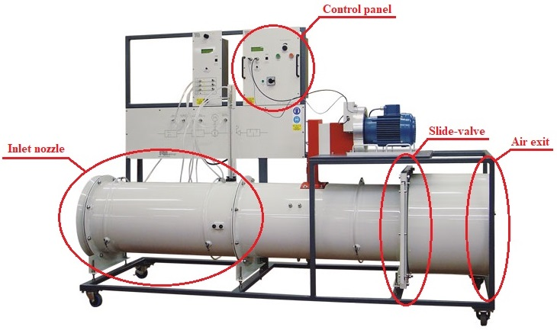

Figure 5‑1. Axial Fan Module MFP107 by TecQuipment [60]

Although the MFP107 Axial Fan Module does not monitor the air speed through the duct directly, its built-in sensors still read the volume metric flow rate, which could still be used to calculate the air speed by dividing it by the cross-section of the duct, whose diameter is 40cm. The test run result is as follows.

|  |  |  |  |  |
| --- | --- | --- | --- | --- |
| **Duct diameter** | **D = 40 cm** |  | **R = 9.2 cm** | **T = 20 s** |
| **Mean flow rate** *fmean***, (m3/s)** | **Machine wind speed** *Vm***, (m/s)** | **Pulse count *n*** | **Read wind speed** *Vs***, (m/s)** | **Factor =** *Vm***/***Vs* |
| 0.85 | 6.764085081 | 30 | 0.433539786 | 15.60199386 |
| 0.91 | 7.241549911 | 55 | 0.794822941 | 9.110896948 |
| 0.958 | 7.623521774 | 92 | 1.329522011 | 5.734032014 |
| 1.022 | 8.132817592 | 135 | 1.950929038 | 4.168689601 |
| 1.14 | 9.071831756 | 176 | 2.543433412 | 3.566765976 |
| 1.33 | 10.58380372 | 254 | 3.670636856 | 2.88336987 |
| 1.44 | 11.4591559 | 289 | 4.176433274 | 2.743766068 |
| 1.56 | 12.41408556 | 329 | 4.754486322 | 2.611025613 |
| 1.65 | 13.13028281 | 370 | 5.346990696 | 2.455639733 |
| 1.78 | 14.16478994 | 383 | 5.534857937 | 2.559196658 |
| 1.9 | 15.11971959 | 437 | 6.315229552 | 2.394167855 |
| 2.03 | 16.15422672 | 505 | 7.297919734 | 2.213538558 |
| 2.15 | 17.10915638 | 538 | 7.774813499 | 2.200587369 |

Table 5‑1. Anemometer test data with the Axial Fan Module MFP107

Although there appears to be a linear association between the read wind speed by the anemometer, this relationship remains inapplicable since the test is limited by the highest fan speed of the Axial Fan Module. However, the wind speed factors between the machine’s and sensor’s values by the read wind speed from the anemometer pose a more practical trend.

Figure 5‑2. Linear association between the anemometer’s and the Axial Fan Module’s wind speeds

Figure 5‑3. Wind speed factors by the read wind speed from the anemometer

It could be observed that at stronger wind, the wind speed factor approaches a certain value. Although the such value appears to be 2 from Figure 5‑3, without the exact model based on aerodynamics, it is uncertain how the anemometer factor really behaves. On the other hand, by the use of Curve Fitting Tool in Matlab, the mathematic model could be estimated. For the time being, the wind speed Vm by the Axial Fan Module is considered the absolute value, and the wind speed read by the anemometer Vs is derived by a factor F following $V_{m}=V_{s}×F$, or $V_{m}=V_{s}×f(V_{s})$ if the factor $F=f(V_{s})$ is considered a function of Vs.

To keep it simple, the function $F=f(V_{s})$ is determined to be a rational function of the same degree on the numerator and the denominator:

$$F=f\left(V_{s}\right)=\sum_{i=0}^{N}{\frac{p_{i}×V_{s}^{N-i}}{q_{i}×V_{s}^{N-i}}}, N≥1$$

For N = 1, the Curve Fitting Tool gives

$$F=f\left(V_{s}\right)=\frac{1.393×V_{s}+5.675}{V_{s}-0.03219}$$

This function, however, is undesirable because it produces a negative factor F as wind speed Vs approaches 0 from + $∞$, resulting in a “real” negative wind speed, which does not exist.

$$\lim_{V_{s}→0}{F=\lim_{V_{s}→0}{f\left(V_{s}\right)=} \frac{1.393×0+5.675}{0-0.03219}≈-176.297 =>\lim_{V_{s→0}}{V_{m}=V_{s}×\lim_{V_{s}→0}{F}<0}}$$

For N = 2, the Curve Fitting Tool gives

|  |  |  |
| --- | --- | --- |
|  | $$F=f\left(V_{s}\right)=\frac{1.698×V_{s}^{2}+3.797×V_{s}+2.632}{V_{s}^{2}-0.002605×V_{s}+0.1079}$$ | (3) |

As the wind speed Vs approaches 0 from $+∞$, the anemometer factor F remains positive, thus a valid value for the real wind speed Vm.

For higher values of N, the Curve Fitting result starts to show fluctuations (Figure 5‑6). The such issue could be avoided by using a rational function model whose numerator degree is different from the denominator degree. However, this solution complicates the software, and potentially introduces computational errors, so the model (3) is the most suitable function for the anemometer F to fix the anemometer behaviour as shown in Table 5‑1.

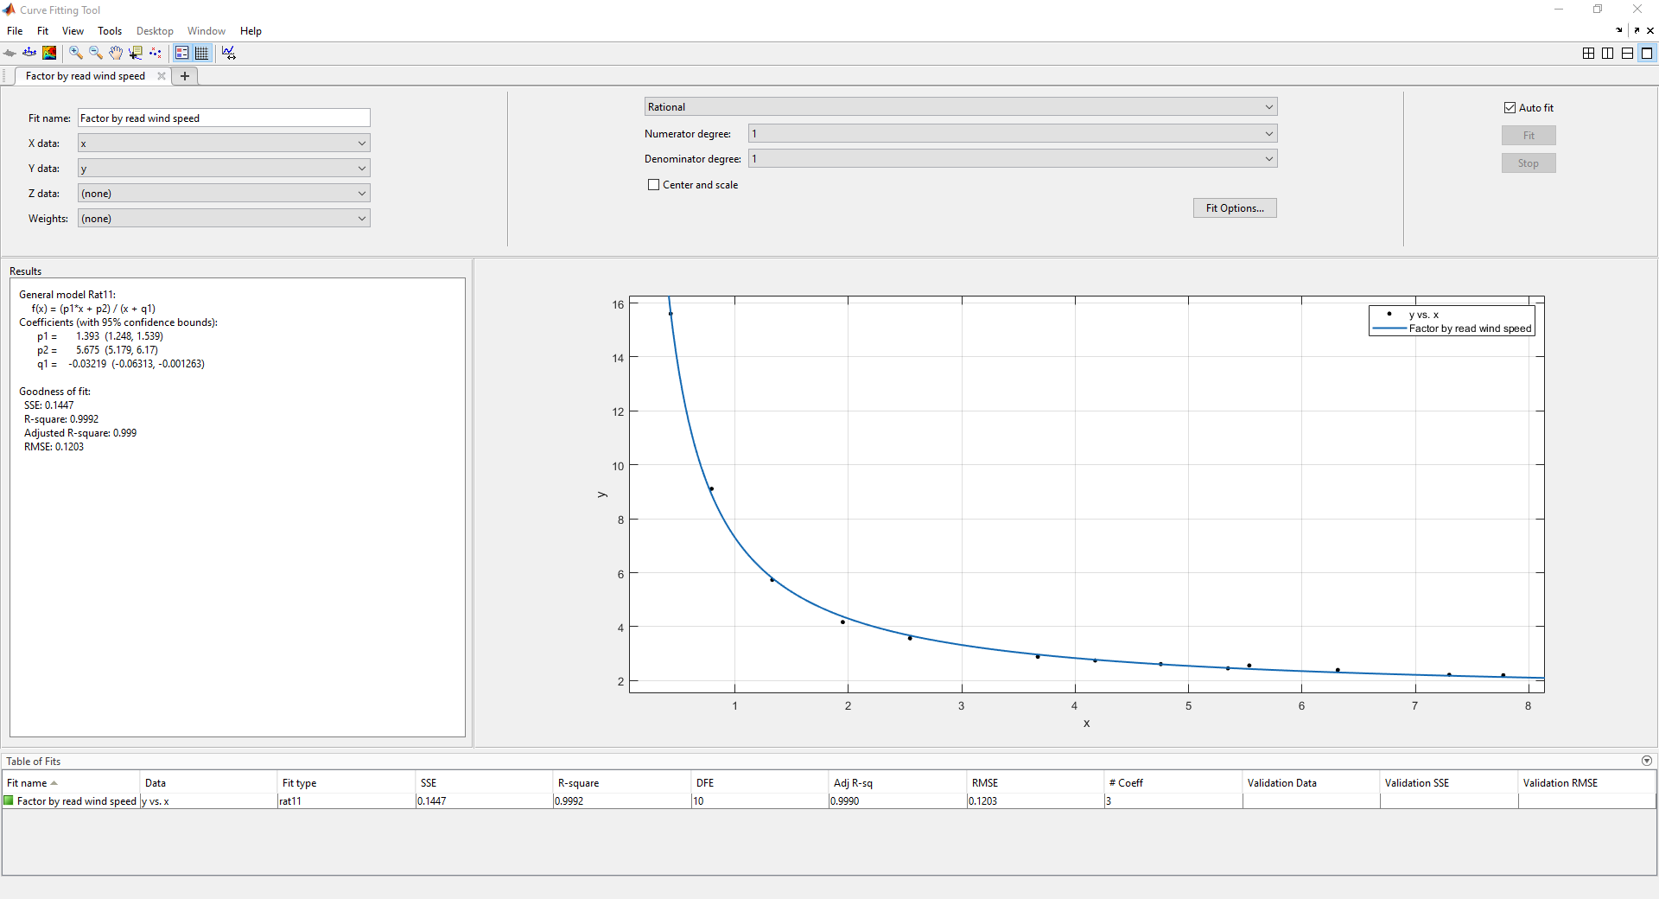

Figure 5‑4. Curve Fitting result for N = 1

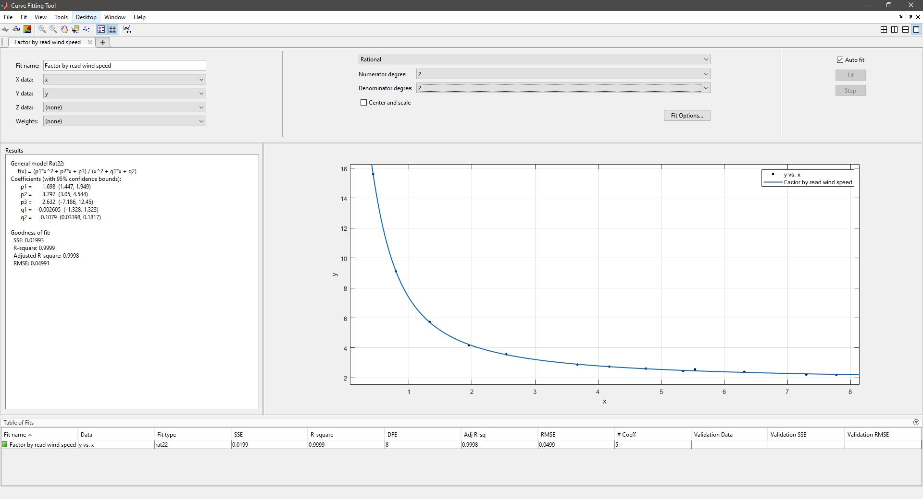

Figure 5‑5. Curve Fitting result for N = 2

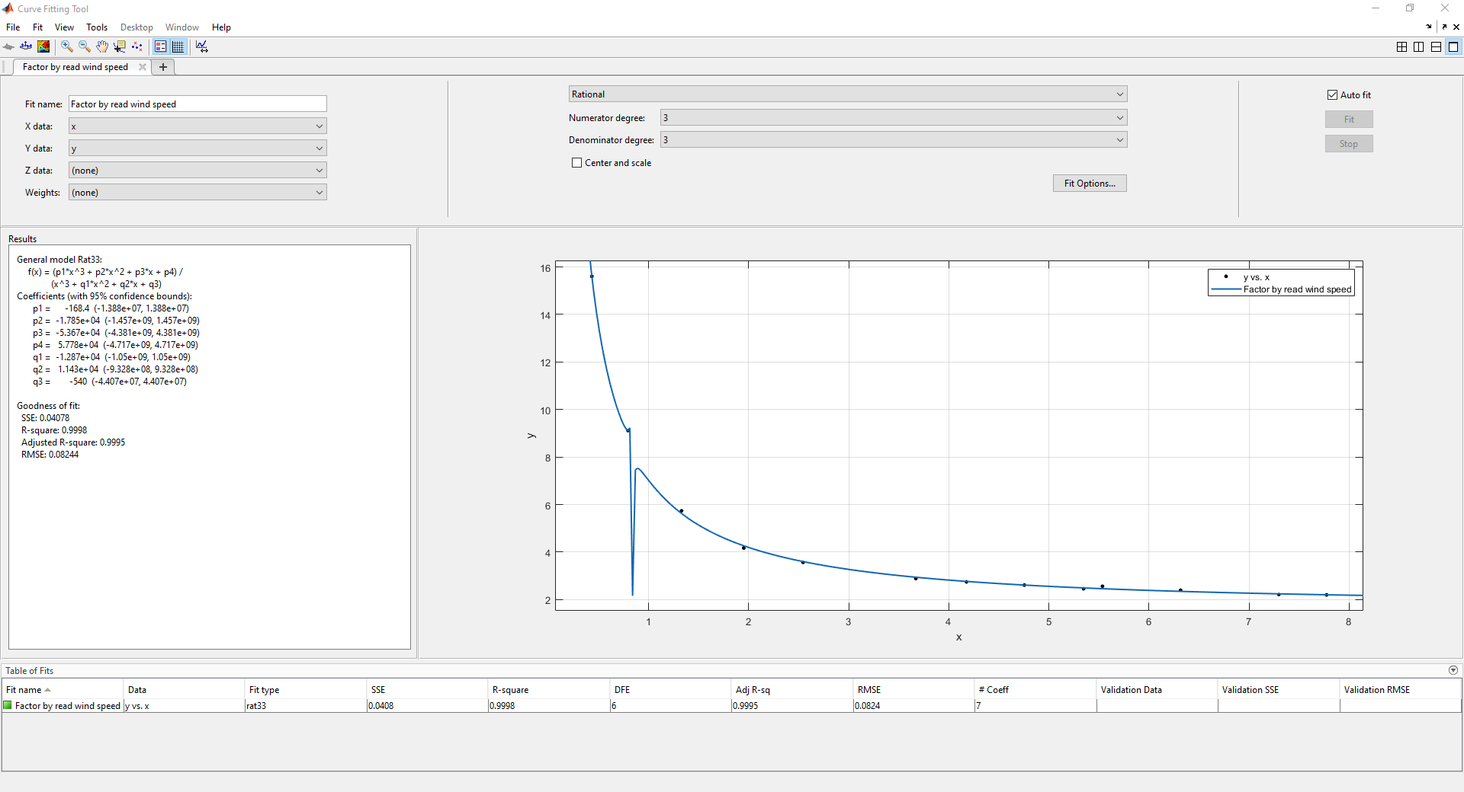

Figure 5‑6. Curve Fitting result for N = 3

## Wind Vane

## Rain Gauge

## Temperature Sensors

## Hygrometer – Barometer

## LoRa Connectivity – ThingSpeak

## LoRa Range Test

The LoRa range test is performed to test the LoRa coverage along with the change of RSSI, SNR, and frequency error of the SX1278 modules when put on the field. The experiment is performed with 2 SX1278 LoRa modules on an open field to ensure they could transfer data on a near line-of-sight. The node is run on an STM32F103C8T6 which receives GPS coordinates via Serial USB Terminal by Kai Morich on a phone; which are then sent uplink to the server via LoRa. The server is run on a nodeMCU-ESP8266, connected to ThingSpeak via Wi-Fi by another phone to upload the node’s GPS coordinates to determine the distances later on.

Figure 5‑7 displays the locations on the Google Maps where the node transmits data to the server. The start point labelled “Start point – 0” is where the node is put next to the server, making the distance virtually 0m.

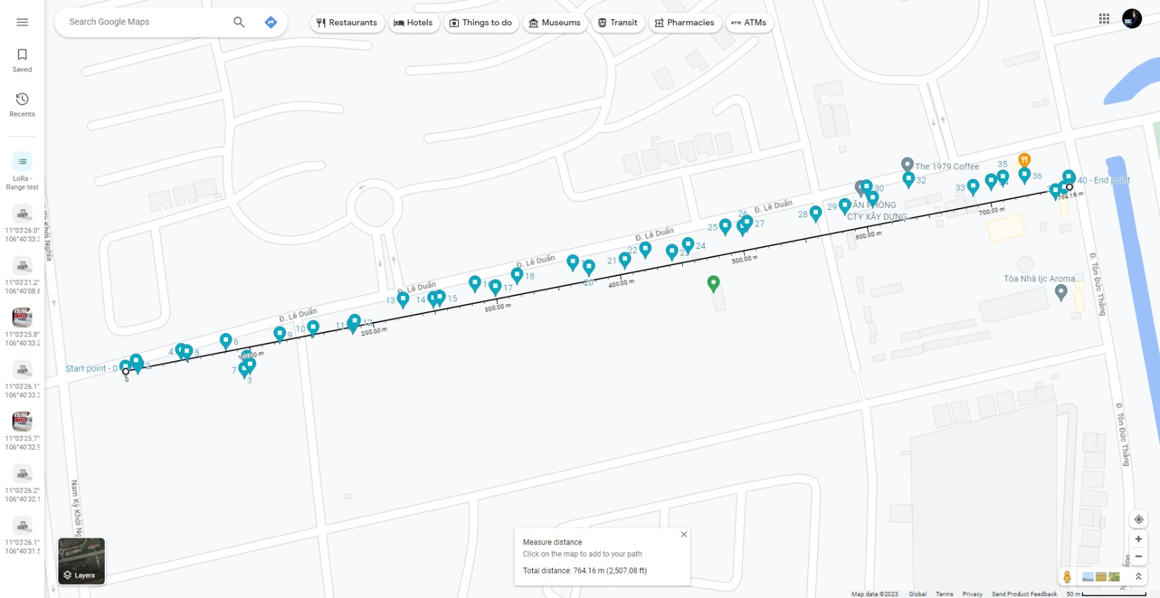

Figure 5‑7. LoRa Range Test – logged locations of LoRa transmissions by the node

In this test, the microcontroller reads the temperature from 1 BME280 device and 2 water-proof DS18B20s. The BME280 communicates with the microcontroller via the I2C protocol and is configured following the recommended settings for weather monitoring in [19]. The DS18B20s are both powered externally and put on separate 1-Wire buses; the thermometer resolution of each device is set to 10-bit. The data reference is taken from a digital thermometer FY-11 whose resolution and accuracy, respectively, are 0.1 ℃ and ±1 ℃ [61].

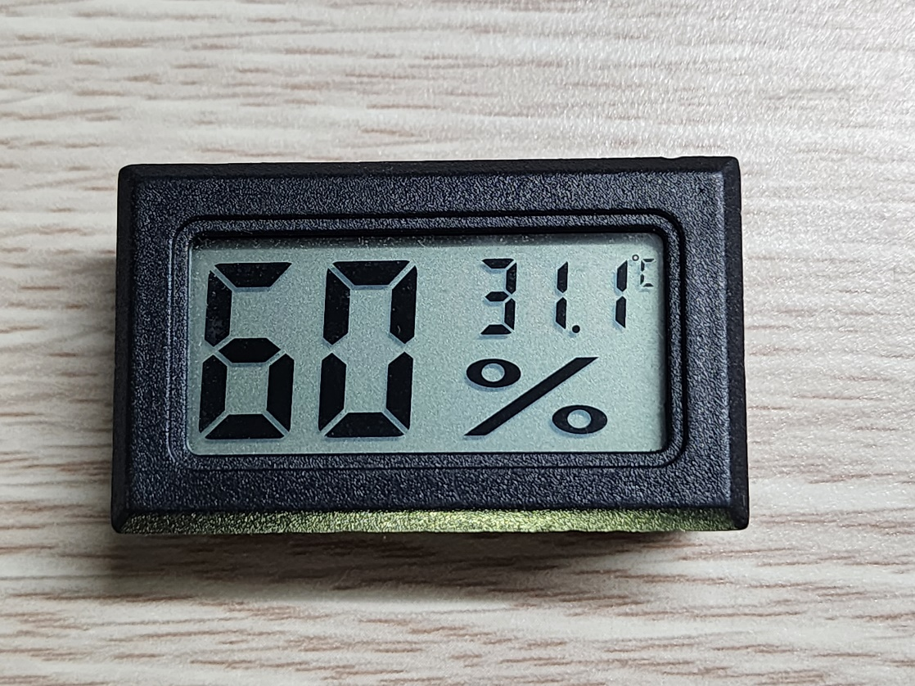

Figure 5‑8. The digital hygrometer – thermometer FY-11 used as reference

The test is performed twice. The first data set consists of 25 entries, while the second has 93. Entries of both sets are recorded approximately 2 minutes apart to reduce timing error by human operations when the BME280 has the lowest data output rate of 1/60 Hz, or 1 sample/minute in weather monitoring mode [19]. For each data entry, the temperature displayed on the reference is input via Serial Monitor to the microcontroller, which then reads the temperature from the sensors and writes to a CSV file on a microSD card.

Figure 5‑9. Temperature sensor behaviours from the first temperature data set

Figure 5‑10. Temperature sensor behaviours from the second temperature data set

The original data sets for Figure 5‑9 and Figure 5‑10 contain the temperature values from the reference FY-11. However, upon building this report is a software defect discovered, which renders the reference entries invalid due to the difference between the input values (floating-point numbers) and the recorded values (integers). The issue does not occur on and affect the recorded temperature data from the BME280 and the DS18B20s. However, without an adequate reference, this test could only compare the temperature sensing units in use.

The BME280 could be seen to produce lower temperature values, up to 0.96 ℃, than the DS18B20s. On the other hand, the data by the BME280 is more stable. During the first run, the smallest temperature change detected by the BME280 is 0.01 ℃, while the largest is 0.72 ℃. The widest gap appears only once between the second and third entries. During the second run, the smallest step remains 0.01 ℃, while the largest is 0.27 ℃. The average temperature change detected by the BME280 from both data sets is 0.05 ℃. The smallest step agrees with the resolution of 0.01 ℃ given in [19].

At the beginning of each run, the ROM code of each DS18B20 is read to distinguish the 2 devices. The temperature difference between the 2 DS18B20s goes up to 0.5 ℃, and the readings by the DS18B20 whose ROM code is 28 AA E7 D1 4D 14 01 20 are always greater than or equal to those by the other sensor. Both detect the temperature change from 0.25 ℃ to 1.5 ℃ per step, with the average of 0.33 ℃. In Figure 5‑10, it is shown that there are some oscillations of 0.25 ℃ between readings of the DS18B20s, which does not happen to the BME208. Since the sampling rate and the resolution of a DS18B20 derived from [22] are, respectively, 1 sample / 187.5 ms and 0.25 ℃, the smallest step of 0.25 ℃ is verified and the oscillation amplitude of 0.25 ℃ is understandable. Should the thermometer resolution be increased, the observed quantities are expected to change accordingly.

## Humidity Sensing Unit

This test is performed simultaneously with the test on temperature sensing units, since the reference FY-11 reads both the temperature and the humidity, like the BME280 sensor. Unlike in the temperature test, the humidity entries by FY-11 are integers due to the 1 %RH resolution [61], thus no problem of conversions from floating-point numbers to integers during card-writing process.

Figure 5‑11. Humidity read by the reference FY-11 and the BME280 sensor in the first run

Figure 5‑12. Humidity read by the reference FY-11 and the BME280 sensor in the second run

In both runs, the BME280 sensor detects humidity change by 0.01 %RH to 1.98 %RH per step, with the exceptions of 3.49 %RH and 3.63 %RH at the beginning of the second run. The average step change is 0.5 %RH. The humidity readings by the BME280 are 0.07 %RH to 2.19 %RH different from those by the hygrometer reference, with the exceptions of 6.92 %RH and 2.43 %RH also at the beginning of the second run. Some oscillations could be observed, especially in Figure 5‑12 due to a longer period of sampling.

Since the hygrometer FY-11 is powered by batteries, it can be considered to have reached saturation before the test. Before the first run, the BME280 has been up for a period of time when software is reviewed and uploaded to the microcontroller. After the first run, the tested system is disconnected from the power source until the second run, when entries are recorded immediately at the beginning. Therefore, it could be assumed that the BME280 needs a period without any operations after being powered in order for the sensing units to initialise properly. Since the entries in this test are taken approximately 2 minutes apart (Section **Error! Reference source not found.**), it is safe to assume that a such period should be up to 4 minutes.

At this point, the first 2 entries in Figure 5‑12 are discarded. If the humidity by the hygrometer FY-11 was absolute, the mean error of the BME280 humidity readings would be 0.85 %RH. However, the hygrometer FY-11 has an accuracy of 5 %RH [61], and a resolution of 1 %RH, it cannot be used as the reference to determine the humidity accuracy by the BME280, but the reference point for evaluations. The humidity accuracy of the BME280 is then accepted to be ±3 %RH by [19]. Moreover, since the minimum resolution of 0.01 %RH is just a rounded number to 2 floating points, and is obtained at the interval higher than the output rate of the BME280 in weather monitoring mode in this test, it is also safe to accept the resolution of 0.008 %RH given by Bosch Sensortec [19].

## InfluxDB Online Database

# Conclusion and Future Work

The conceptual design of an Autonomous Wireless Agrometeorology Station introduces a new solution for improvements of agricultural production via monitoring the meteorological factors, including wind parameters, precipitations, temperature, humidity, and atmospheric pressure. However, this design remains incomplete due to testing limitations.

The available results suggest that the digital sensors are reliable, and remote data access in real time is possible with InfluxDB. By concept, the analogue sensors for wind and rain data could produce adequate data with suitable circuitries and software. Further evaluations on each module are required to improve the current setups and advance to build a working protype.

For the time being, the work to be done includes:

* Evaluation of the anemometer. Although testing equipment is currently unavailable, the aerodynamics of movements in an open space may be investigated to build alternative test conditions.
* Improvement of wind vane resistance readings. The analogue LPF has been proved to improve the readings from the wind vane, yet errors persist. A digital filter may be a solution for the existing issues.
* Evaluation of the rain gauge. The working principles of a traditional rain gauge are to be studied to build adequate test conditions for a tipping bucket.
* Further evaluations of the digital sensors.
* Thorough evaluations of the SX1278 LoRa modules, including tests on signal coverage, data rate, drop rate, power consumption, etc.
* Development and evaluation of the system powering unit, which contains a solar panel and battery storage system.
* Integration of all modules on a single prototype and move from a concept to a real design.

# References

[1] H. N. Do, “Conceptual Design of an Autonomous Wireless Agrometeorology Station,” 2023.

[2] E. Fahad, “Microcontroller Selection Criteria for your project, 8 bit Vs 16 bit Microcontroller,” *Electronic Clinic*, 2021. https://www.electroniclinic.com/microcontroller-selection-criteria-for-your-project-8-bit-vs-16-bit-microcontroller/.

[3] J. Koon, “Key factors to consider when choosing a microcontroller,” *Micrcontroller Tips*, 2019. https://www.microcontrollertips.com/key-factors-consider-choosing-microcontroller/.

[4] EntcEngg Team, “Criteria for Choosing a Microcontroller.” 2017, [Online]. Available: https://www.entcengg.com/criteria-choosing-microcontroller/.

[5] Robocraze, “How to choose a microcontroller,” *Robocraze*, 2021. https://robocraze.com/blogs/post/selecting-a-microcontroller-for-your-projects.

[6] Texas Instruments, “Benefits and Issues on Migration of 5-V and 3.3-V Logic to Lower-Voltage Supplies,” 1999. [Online]. Available: https://www.ti.com/lit/an/sdaa011a/sdaa011a.pdf.

[7] STM32-base, “Blue Pill,” *STM32-base*. https://stm32-base.org/boards/STM32F103C8T6-Blue-Pill.html.

[8] STMicroelectronics, “STM32F101xx, STM32F102xx, STM32F103xx, STM32F105xx and STM32F107xx advanced Arm®-based 32-bit MCUs,” no. February 2021. 2021.

[9] STMicroelectronics, “STM32F103x8, STM32F103xB.” pp. 1–116, 2022.

[10] M. Cardinali, “The importance of weather data in agriculture,” *Agricolus*, 2022. https://www.agricolus.com/en/the-importance-of-weather-data-in-agriculture/.

[11] B. Gardiner, P. Berry, and B. Moulia, “Review: Wind impacts on plant growth, mechanics and damage,” *Plant Sci.*, vol. 245, pp. 94–118, Apr. 2016, doi: 10.1016/j.plantsci.2016.01.006.

[12] E. de Langre, “Effects of Wind on Plants,” *Annu. Rev. Fluid Mech.*, vol. 40, no. 1, pp. 141–168, Jan. 2008, doi: 10.1146/annurev.fluid.40.111406.102135.

[13] Misol Electronics, “misol SP-WS02 Spare part (outdoor unit) for Professional Wireless Weather Station.” http://www.misolweather.com/index.php?m=home&c=View&a=index&aid=60.

[14] S. Pindado, J. Cubas, and F. Sorribes-Palmer, “The Cup Anemometer, a Fundamental Meteorological Instrument for the Wind Energy Industry. Research at the IDR/UPM Institute,” *Sensors*, vol. 14, no. 11, pp. 21418–21452, Nov. 2014, doi: 10.3390/s141121418.

[15] Argent Data System, “Weather Sensor Assembly p / n 80422.” 2014, [Online]. Available: https://www.argentdata.com/files/80422_datasheet.pdf.

[16] T. Reed, “Multimeter Measurements Explained,” *Electronic Design*, 2020.

[17] Misol Electronics, “Professional Weather Station (Wind and Air Pressure) - Operational Manual.” pp. 1–24.

[18] Bosch Sensortec GmbH, “Humidity sensor BME280,” *Bosch Sensortec GmbH*. https://www.bosch-sensortec.com/products/environmental-sensors/humidity-sensors-bme280/#description.

[19] Bosch Sensortec GmbH, “BME280 Environmental Sensor,” *Bosch Sensortec GmbH*. Jan. 2022.

[20] Linh Kiện 888, “Cảm Biến Áp Suất BME280 3.3V.” https://linhkien888.vn/cam-bien-ap-suat-bme280-3-3v.

[21] C. Petrich, N. P. Dang, I. Sæther, Ø. Kleven, and M. O’Sadnick, “A Note on Remote Temperature Measurements with DS18B20 Digital,” 2020, [Online]. Available: https://hdl.handle.net/11250/2716073.

[22] Maxim Integrated, “DS18B20.” 2019, [Online]. Available: https://datasheets.maximintegrated.com/en/ds/DS18B20.pdf.

[23] M. Fezari and A. Al Dahoud, *Exploring One-wire Temperature sensor “DS18B20” with Microcontrollers*. 2019.

[24] S. Budijono and Felita, “Smart Temperature Monitoring System Using ESP32 and DS18B20,” *IOP Conf. Ser. Earth Environ. Sci.*, vol. 794, no. 1, p. 012125, Jul. 2021, doi: 10.1088/1755-1315/794/1/012125.

[25] Widodo and E. A. Stiyawan, “Design of Total Dissolve Solid (Tds) Measuring Using Conductivity Sensor and Temperature Sensor Ds18B20,” *BEST J. Appl. Electr. Sci. Technol.*, vol. 2, no. 1, pp. 25–29, 2020, doi: 10.36456/best.vol2.no1.2583.

[26] Process Parameters Ltd, “HOW TO CALIBRATE PT100 TEMPERATURE SENSOR,” *Process Parameters Ltd*. https://www.processparameters.co.uk/how-to-calibrate-pt100/.

[27] Thegioiic, “DS18B20-1M Digital Temperature Sensor.” https://www.thegioiic.com/ds18b20-day-cam-bien-nhiet-do-1m.

[28] Thegioiic, “AM2315 Temperature And Humidity Module.” https://www.thegioiic.com/am2315-cam-bien-nhiet-do-do-am.

[29] B. Linke, “Reading and Writing 1-Wire® Devices Through Serial Interfaces,” 2009.

[30] Texas Instruments, “Implementing 1-Wire Enumeration for TMP1826 With TM4C129x Microcontrollers.” 2018, [Online]. Available: https://www.ti.com/lit/an/spma057d/spma057d.pdf.

[31] Speedtest® by Ookla®, “Speedtest Global Index,” *Speedtest® by Ookla®*. https://www.speedtest.net/global-index/vietnam.

[32] B. Mitchell, “What is the Range of a Typical Wi-Fi Network?,” *Lifewire*. 2020, [Online]. Available: https://www.lifewire.com/range-of-typical-wifi-network-816564%0Ahttp://compnetworking.about.com/cs/wirelessproducts/f/wifirange.htm.

[33] J. G. Sponås, “Things You Should Know About Bluetooth Range,” *Get Connected Blog*, 2023. https://blog.nordicsemi.com/getconnected/things-you-should-know-about-bluetooth-range.

[34] A. Lavric and V. Popa, “Performance Evaluation of LoRaWAN Communication Scalability in Large-Scale Wireless Sensor Networks,” *Wirel. Commun. Mob. Comput.*, vol. 2018, pp. 1–9, Jun. 2018, doi: 10.1155/2018/6730719.

[35] A. Ambanloc, “What Communication Protocol to Use and When,” *NeuronicWorks*. https://neuronicworks.com/blog/wireless-communication-protocols/.

[36] Voler Systems, “Wireless Communication Choices for IoT Designs,” *Voler Systems*. https://www.volersystems.com/blog/wireless-communication-choices-for-iot-designs.

[37] EPB, “How Far Will Your Wi-Fi Signal Reach?,” *EPB.com*. https://epb.com/get-connected/gig-internet/how-far-will-your-wi-fi-signal-reach/.

[38] Tessie, “HC-06 vs. HC-05 Bluetooth Module: What is the difference between HC-06 and HC-05?,” *Utmel Electronics*, 2021. https://www.utmel.com/components/hc-06-vs-hc-05-bluetooth-module-what-is-the-difference-between-hc-06-and-hc-05?id=889.

[39] A. Wang, “Comparison between LoRa and other wireless technologies,” *MOKOLoRa*, 2021. https://www.mokolora.com/lora-and-wireless-technologies/.

[40] Thegioiic, “Zigbee Modules.” https://www.thegioiic.com/product/mach-zigbee.

[41] Thegioiic, “RF Transceivers.” https://www.thegioiic.com/product/mach-thu-phat-rf.

[42] Semtech, “Semtech SX1276,” *Wirel. Sens. Prod.*, no. May, 2020, [Online]. Available: https://www.semtech.com/products/wireless-rf/lora-core/sx1276.

[43] HeyPete, “Major differences between the DS3231 and DS3231M RTC chips.” 2017, [Online]. Available: https://blog.heypete.com/2017/09/05/major-differences-between-the-ds3231-and-ds3231m-rtc-chips/.

[44] HeyPete, “DS3231 Drift Results (5 months).” 2018, [Online]. Available: https://blog.heypete.com/2018/02/04/ds3231-drift-results-5-months/.

[45] Maxim Integrated, “DS3231.” 2015.

[46] Omega Engineering, “Sources of Noise and Some Typical Solutions,” *Omega Engineering*. https://www.omega.co.uk/techref/das/noise.html.

[47] J. Heath, “Electrical noise can come from anywhere,” *Analog IC Tips*, 2021. https://www.analogictips.com/electrical-noise-can-come-from-anywhere/.

[48] V. Muthukrishnan, “Cutoff Frequency: What is it? Formula And How To Find it,” *Electrical4U*, 2022. https://www.electrical4u.com/cutoff-frequency/.

[49] SparkFun, “Pull-up Resistors,” *SparkFun*. https://learn.sparkfun.com/tutorials/pull-up-resistors/all (accessed Jul. 26, 2023).

[50] J. Christoffersen, “Switch Bounce and How to Deal with It,” *All About Circuits*, 2015. https://www.allaboutcircuits.com/technical-articles/switch-bounce-how-to-deal-with-it/.

[51] Texas Instruments, “Debounce a Switch.” 2020.

[52] J. W. Nilsson and S. A. Riedel, “The Step Response of RL and RC Circuits,” in *Electric Circuits*, 10th ed., Pearson Education, Inc., 2015, pp. 224–231.

[53] Electronics Tutorials Team, “RC Charging Circuit.” https://www.electronics-tutorials.ws/rc/rc_1.html.

[54] STMicroelectronics, “Arduino_Core_STM32.” [Online]. Available: https://github.com/stm32duino/Arduino_Core_STM32.

[55] Z. Peterson, “ADC Sampling Rate and Layout for Mixed Signal Boards,” *Altium Limited*, 2020. https://resources.altium.com/p/adc-sampling-rate-and-layout-mixed-signal-boards.

[56] N. Abbas, “SPI vs I2C vs UART: In-Depth Comparison,” *Wevolver*, 2023. https://www.wevolver.com/article/spi-vs-i2c-vs-uart-in-depth-comparison.

[57] Ladyada, “Adafruit_BME280_Library.” [Online]. Available: https://github.com/adafruit/Adafruit_BME280_Library.

[58] I. Analog Devices, “How to Power the Extended Features of 1-Wire® Devices,” *Analog Devices, Inc.* https://www.analog.com/en/technical-articles/how-to-power-the-extended-features-of-1wire-devices.html.

[59] I. Advanced Monolithic Systems, “AMS1117 1A LDO Voltage Regulator,” *Datasheet*. 2009.

[60] AYVA Educational Solutions, “TecQuipment Axial Fan Module – MFP107,” *AYVA Educational Solutions*. https://www.tecquipment.com/axial-fan-module.

[61] Thegioiic, “FY-11 Digital LCD Thermometer Hygrometer.” https://www.thegioiic.com/fy-11-dong-ho-nhiet-do-do-am.